**C0766552_MidTerm_MAD3115W2020**

MAD3115

Documentation of Mid Term

Billing System

C0766552

Nikita Sandhu

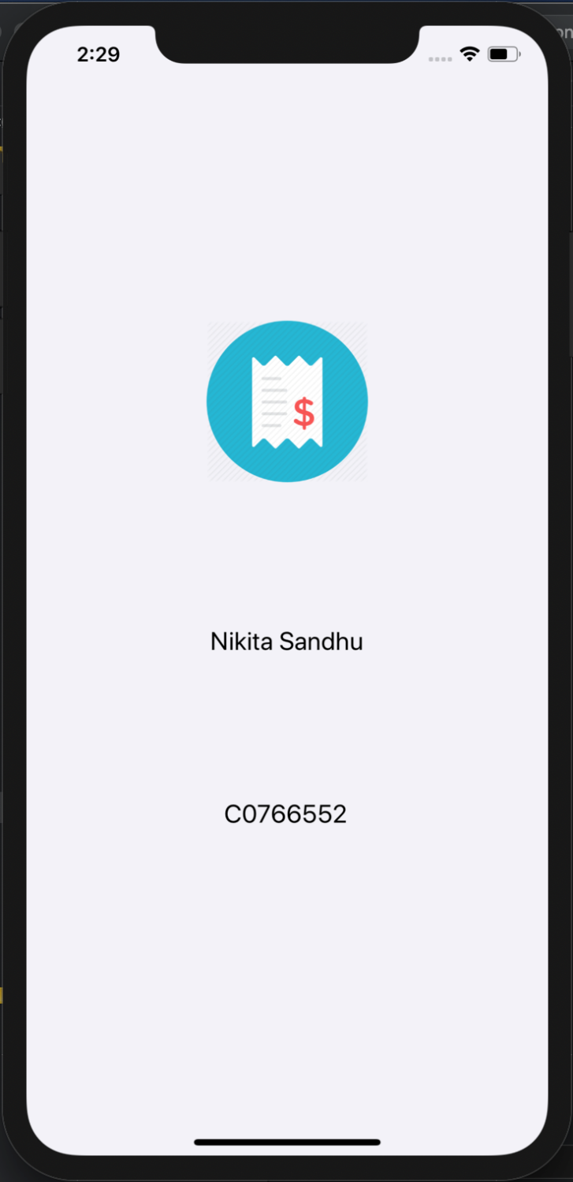

Fig 1. Launch VIEW CONTROLLER

* This is the first screen that will appear when the application is started, this is the launch screen.
* This will appear for a significant amount of time and then the next VIEW CONTROLLER WILL appear.

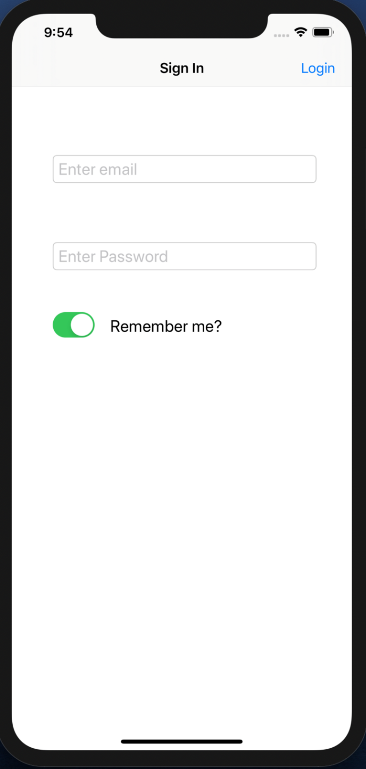

Fig 2. Login VIEW CONTROLLER

* Login Screen requires an email and the consecutive password to login into the application and these are the TEXTFIELDs.
* There is a remember me SWITCH.
* Login BAR BUTTON is there.

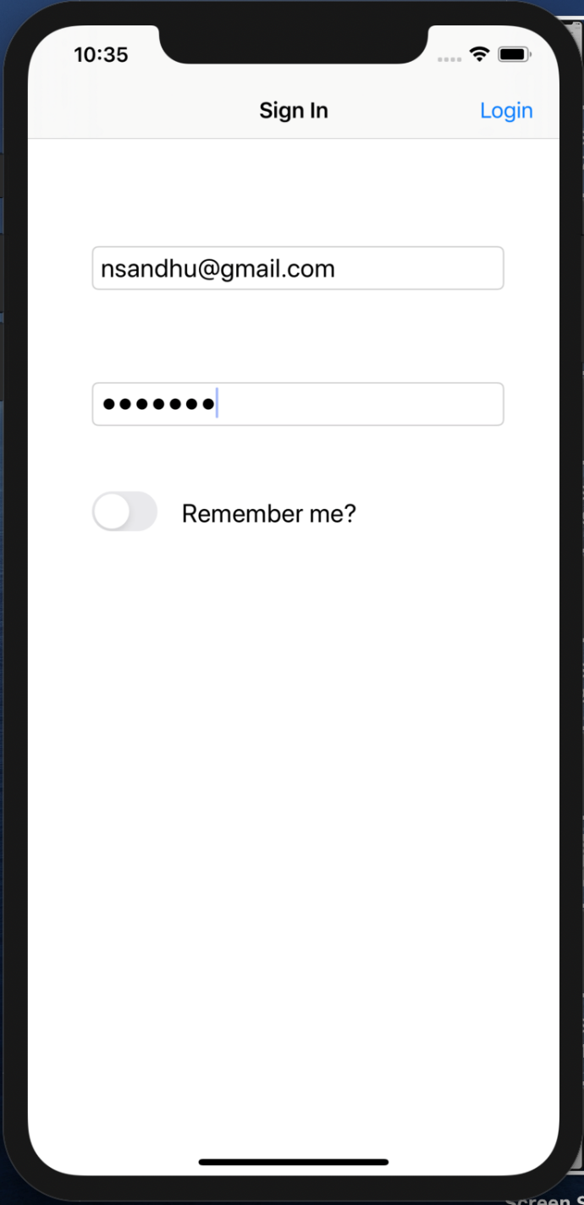

Fig 3. Logging in with Remember me OFF

* The remember me SWITCH can be turned ON or OFF according to preference.
* The user details are entered.
* Login BAR BUTTON is pressed to log into the application.

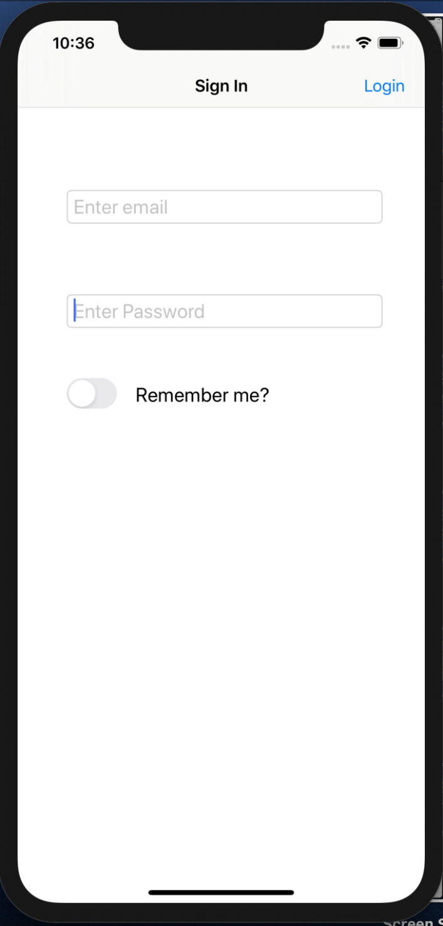

Fig 4. Logging Out when Remember me OFF

* When the user Logs out of the application and the Remember me SWITCH was turned OFF when the user logged into the application in the first place then user details will not be saved and user has to enter the login details again in order to login.

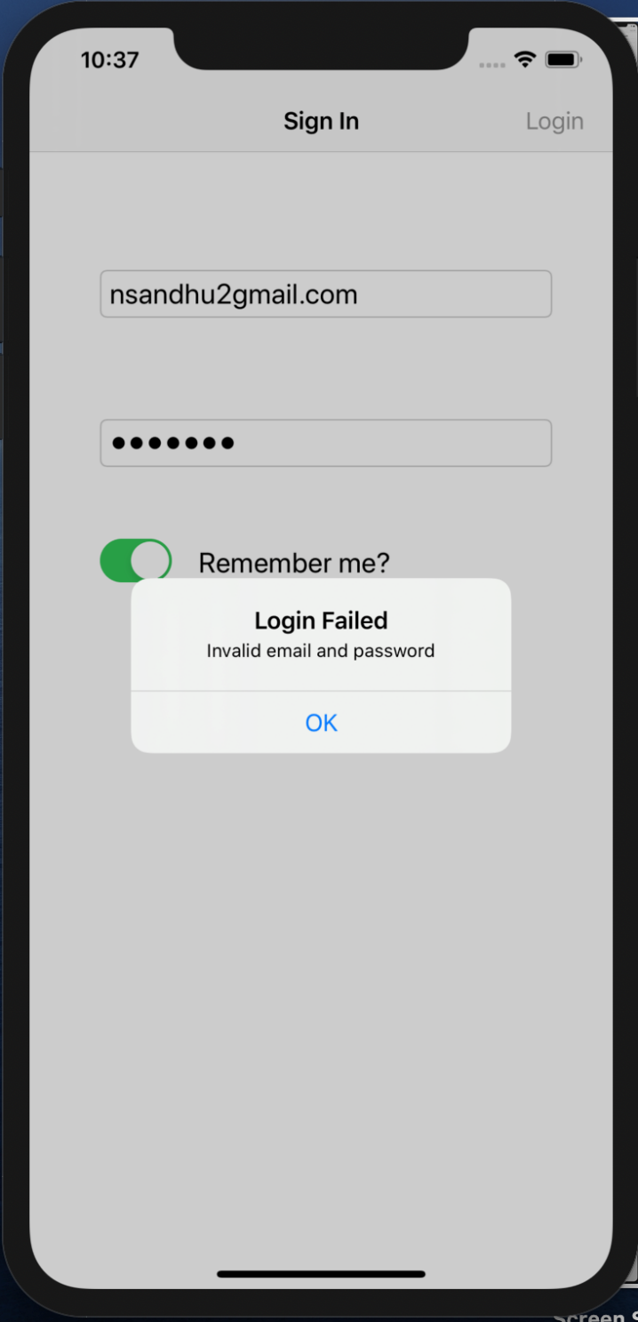

Fig 5. Login with Login Validation

* Login process requires a valid email and password.
* In this application one user email and password detail is fixed and the same needs to be entered in order to login.

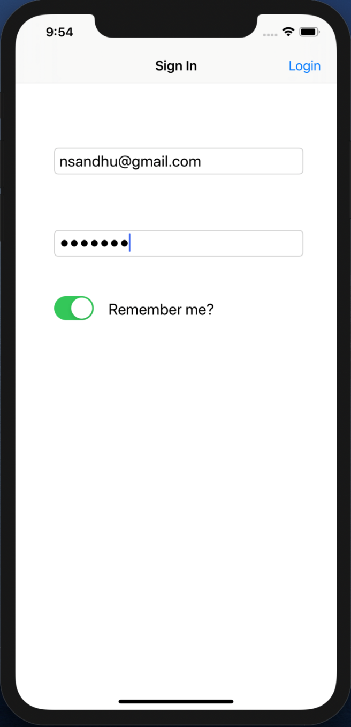

Fig 6. Login with Remember me ON

* When the user Logs out of the application and the Remember me SWITCH was turned ON when the user logged into the application in the first place then user details will be saved and user doesn’t have to enter the login details again in order to login.

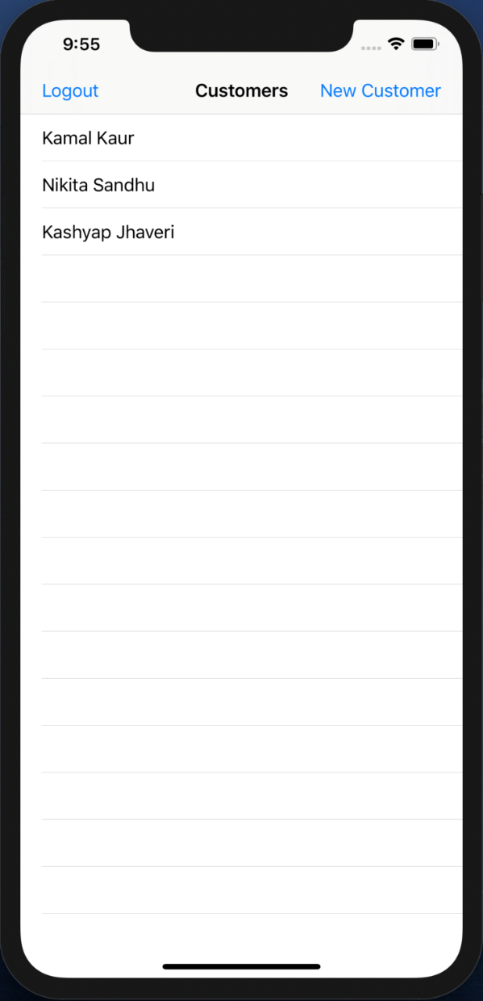

Fig 7. List of Customers VIEW CONTROLLER

* After logging in the Customers list appears, it is a TABLE VIEW.
* There is a Logout BAR BUTTON.
* There is a New Customer BAR BUTTON that is used to create a new customer.

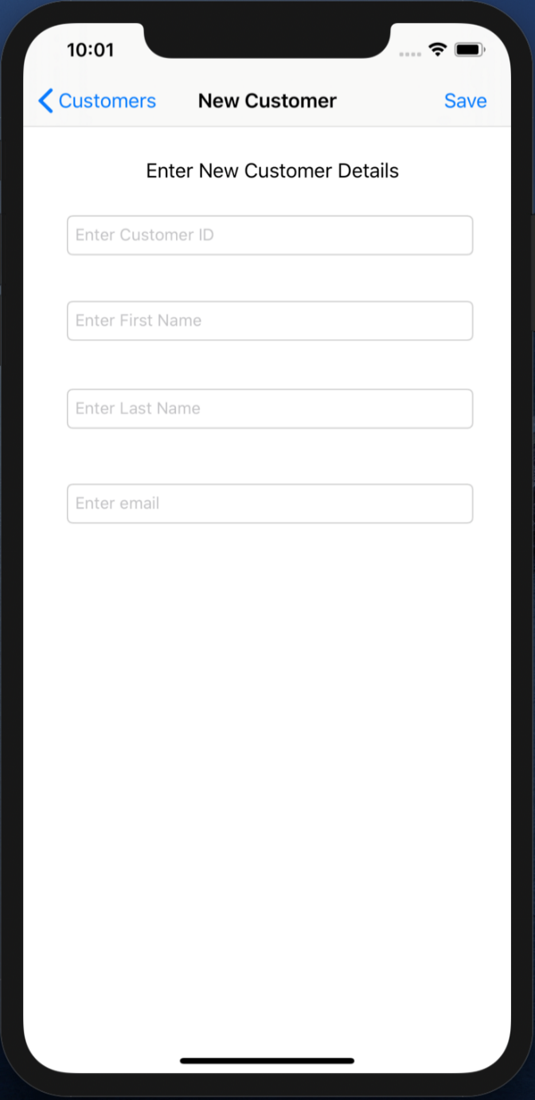

Fig 8. New Customer creation

* When the New Customer BAR BUTTON is pressed a new screen appears.
* This screen contains TEXTFIELDs that shows the requirements that needs to be entered in order to create a new customer.
* When no new customer is needed to be created then the user can simple press the Customers back BAR BUTTON on the top left and go back to the previous screen.

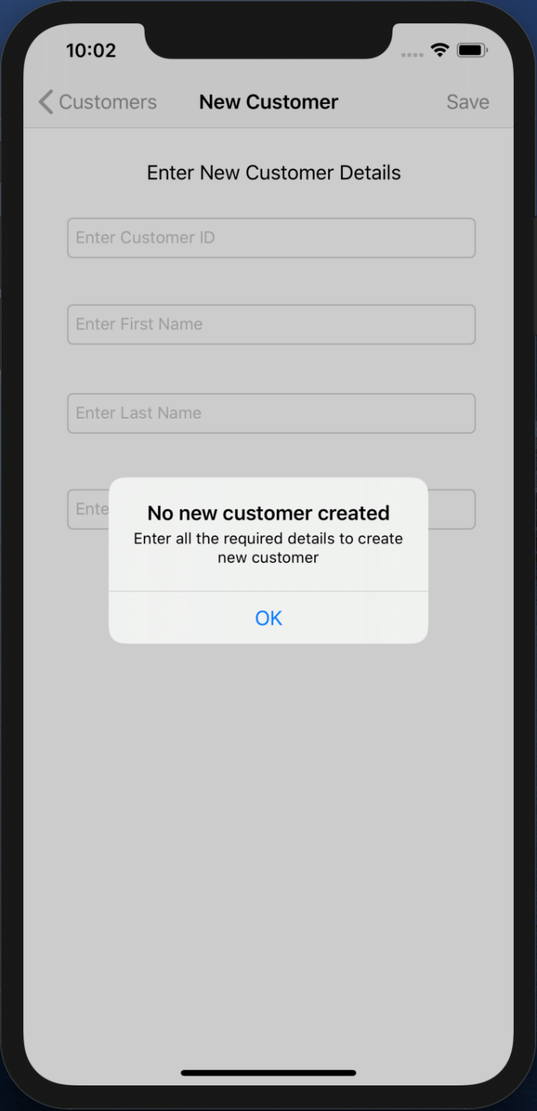

Fig 9. Alert

* When the save button is pressed without entering any of the details of the new customer that is needed to be created, an ALERT pops up.
* This alert shows a message asking to fill the details that are required to create a new customer.

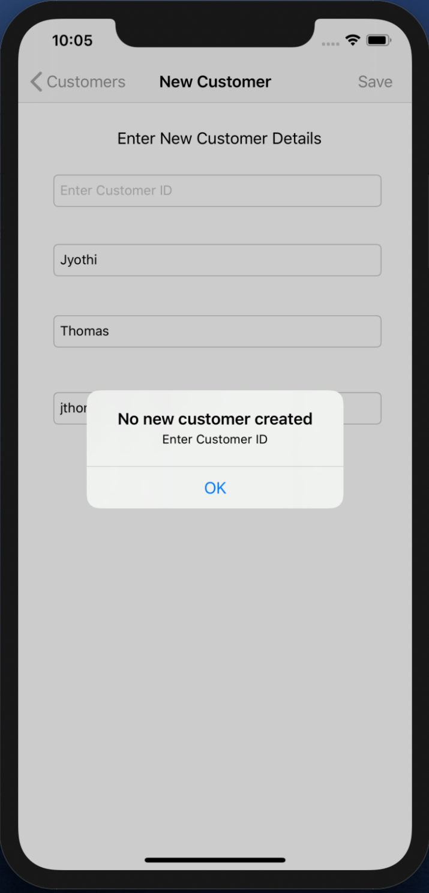

Fig 10. Alert

* An alert will pop up, when Customer’s ID is not filled.

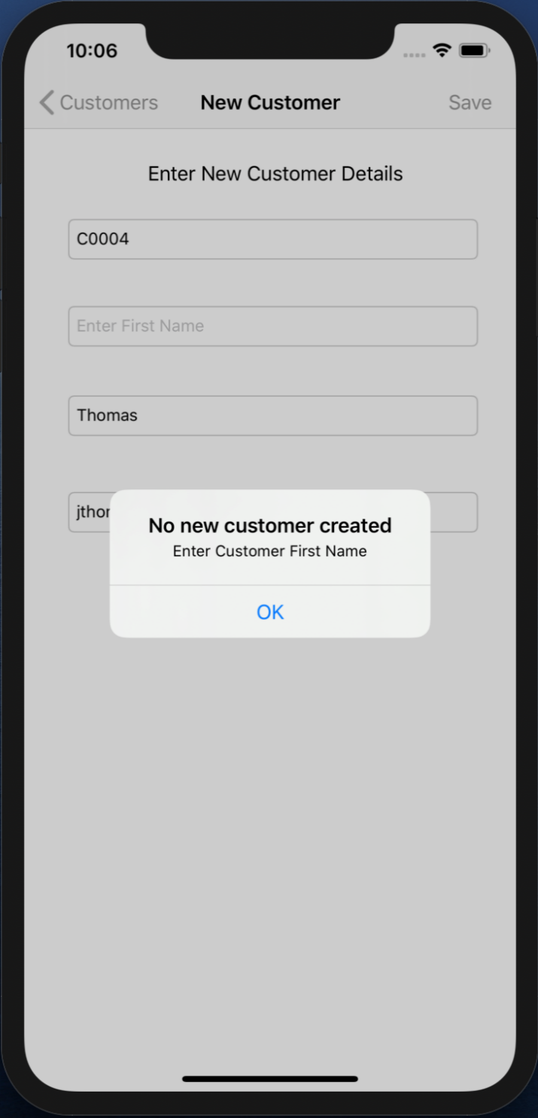

Fig 11. Alert

* An alert will pop up, when the Customer’s First Name is not filled.

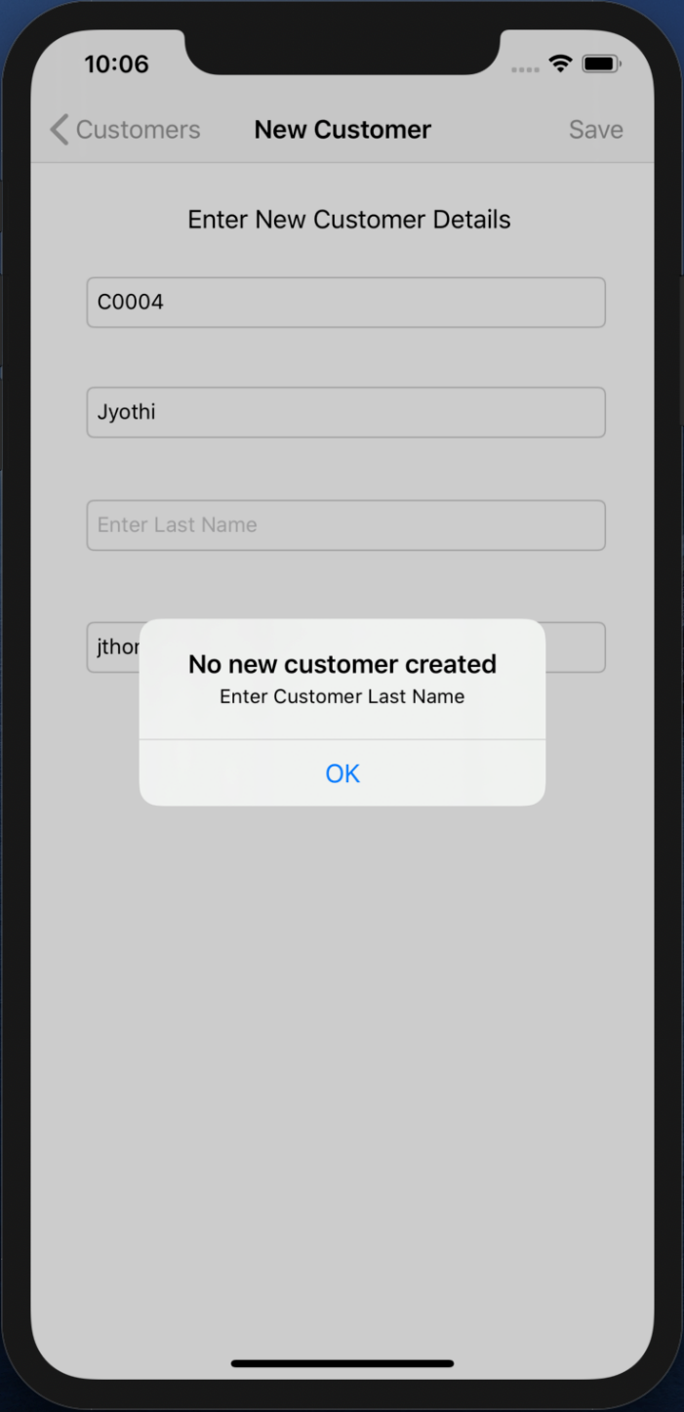

Fig 12. Alert

* An alert will pop up, when the Customer’s Last Name is not filled.

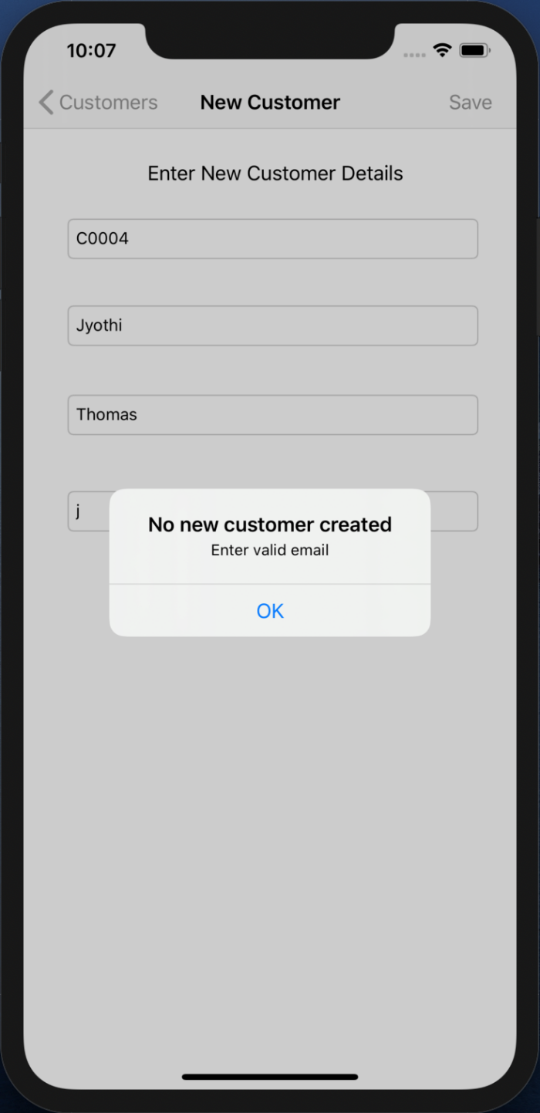

Fig 13. Alert

* An alert will pop up, when valid email for the customer to be created is not entered.

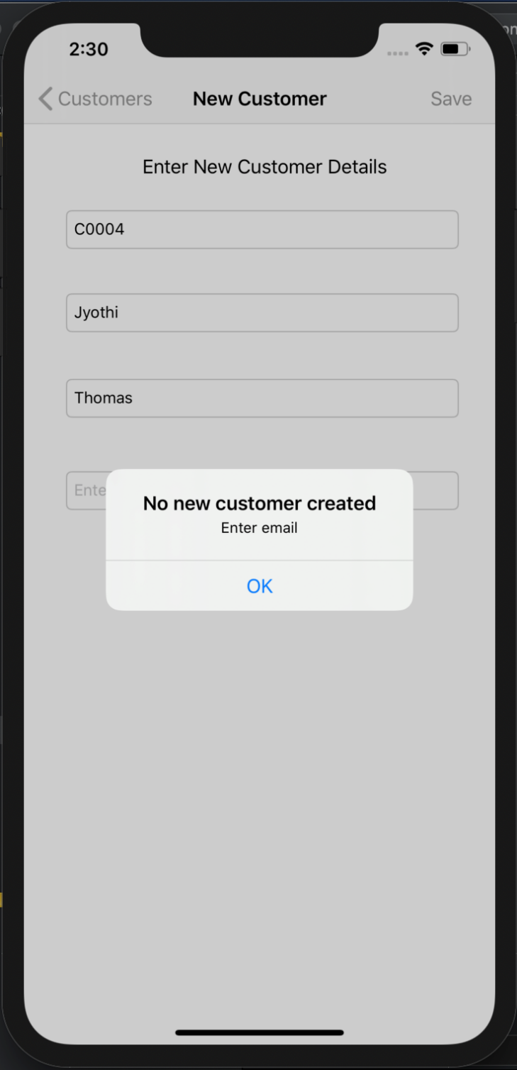

Fig 14. Alert

* An alert will pop up, when email for the customer to be created is not entered.

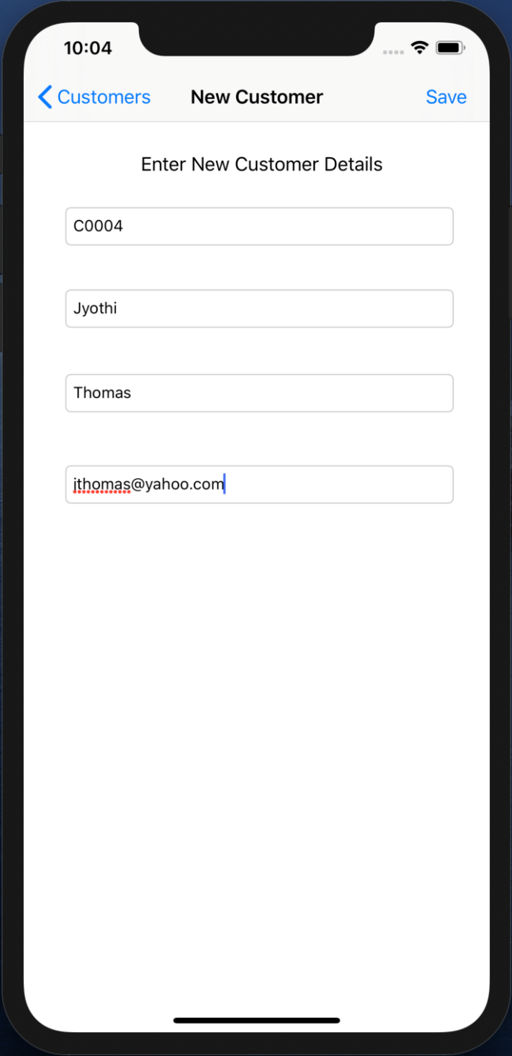

Fig 15. New Customer details entered

* All the details are filled and Save BAR BUTTON is pressed.
* This will create a new Customer object and pop this VIEW CONTROLLER.

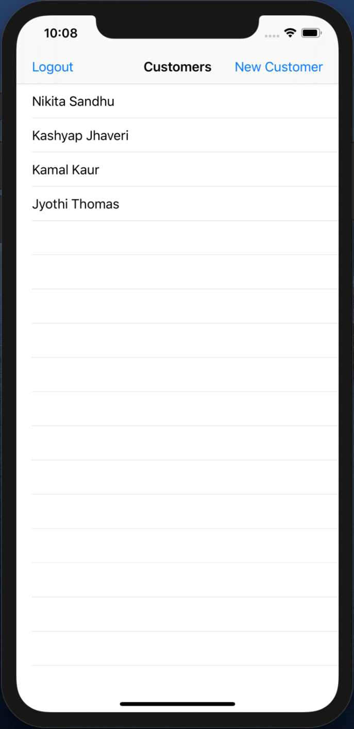

Fig 16. New Customer appears Customers TABLE VIEW

* The Customer List VIEW CONTROLLER will get updated when the new customer is created.
* Each of these customers have their own details that can be viewed by clicking the customer name.

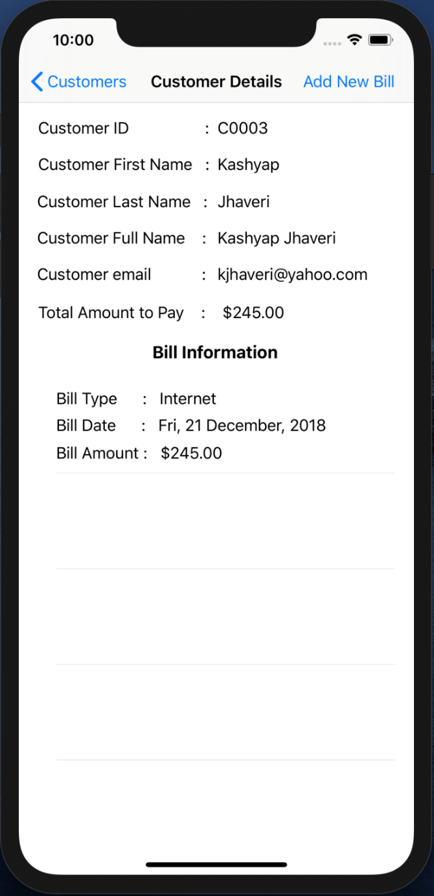

Fig 17. Customer with one bill

* When particular customer is selected then a new VIEW CONTROLLER pops up that has the detailed information about the particular customer.
* There is a Add New Bill BAR BUTTON that can be used to add new bills for the particular customer.
* This customer only has one bill that is of Internet type.

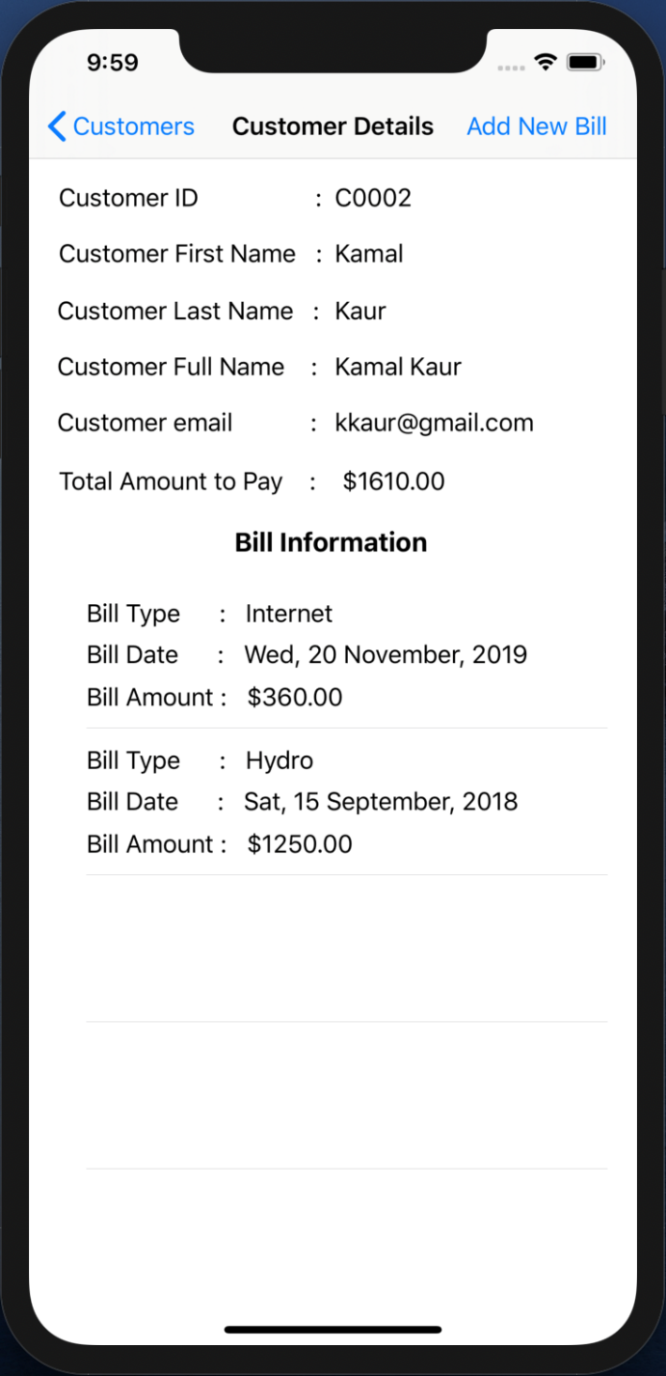

Fig 18. Customer with two bills

* This customer has two bills that are of Internet and Hydro types.

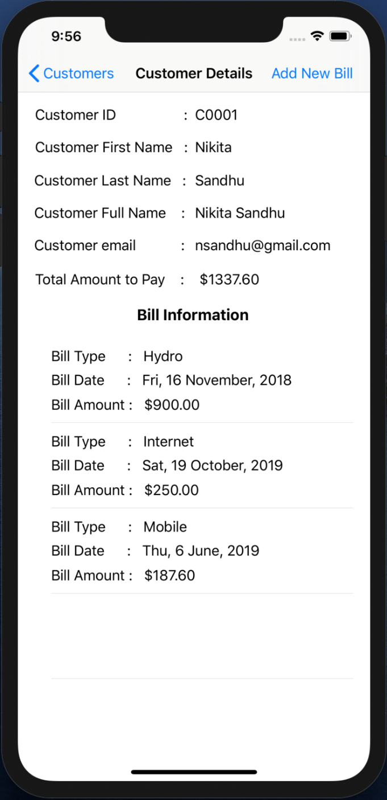

Fig 19. Customer with three bills

* This customer has three bills of types Hydro, Internet and Mobile.
* More details information of the bill can be retrieved by just clicking on the particular bill type.

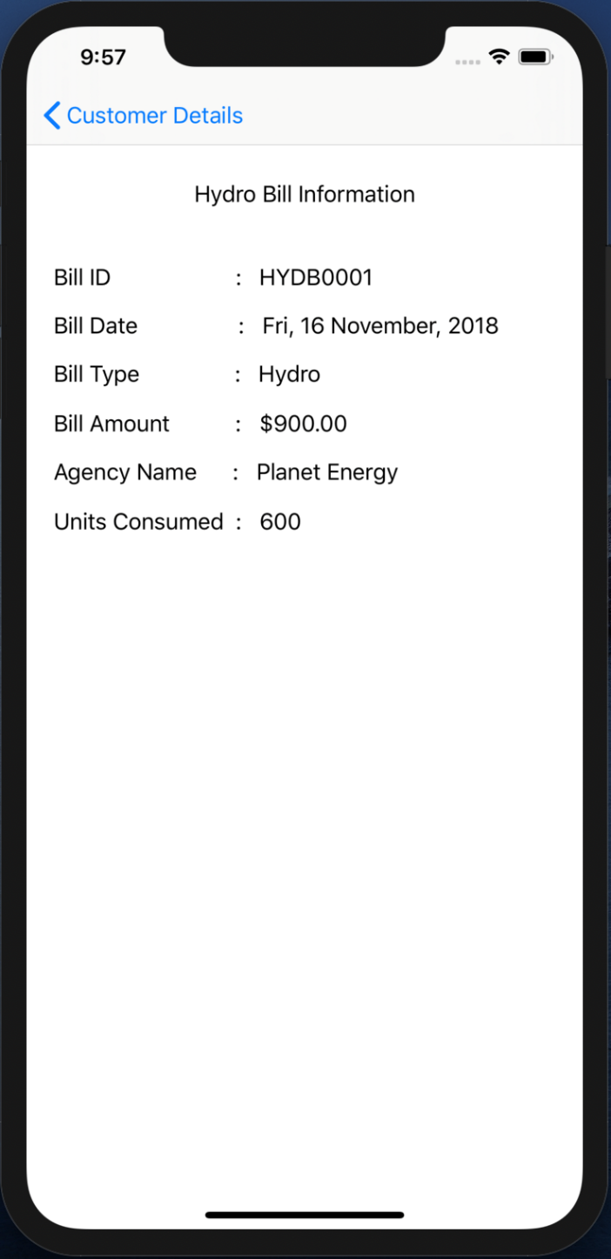

Fig 20. Hydro Bill Information

* Only a single VIEW CONTROLLER is used to display the information about the different types of bills.
* Here the details information about the Hydro Bill is displayed.

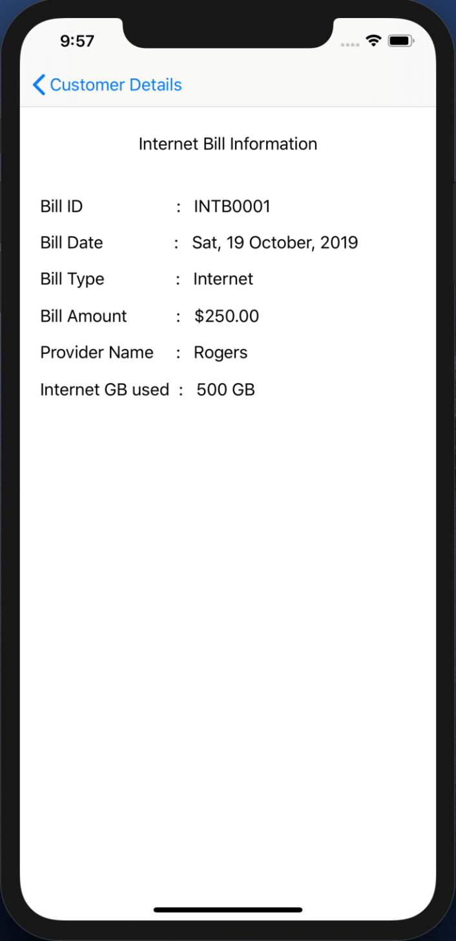

Fig 21. Internet Bill Information

* Here the details information about the Internet Bill is displayed.

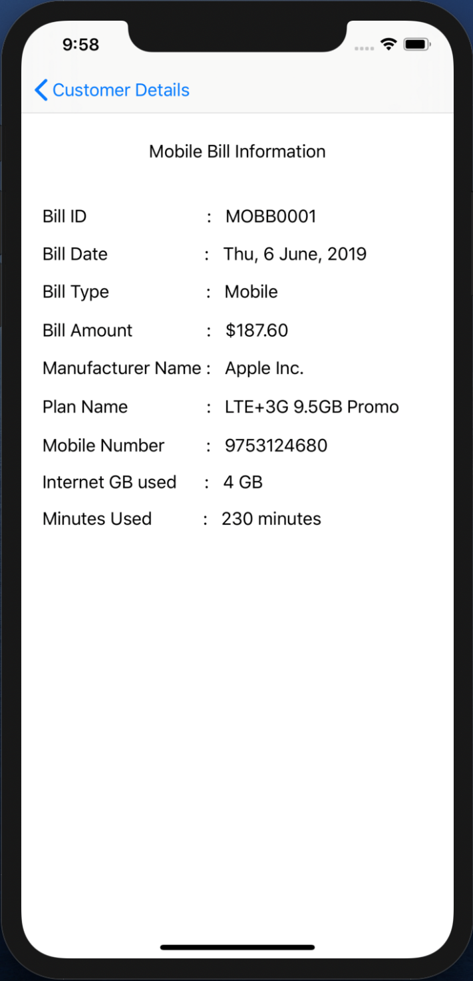

Fig 22. Mobile Bill Information

* Here the details information about the Mobile Bill is displayed.

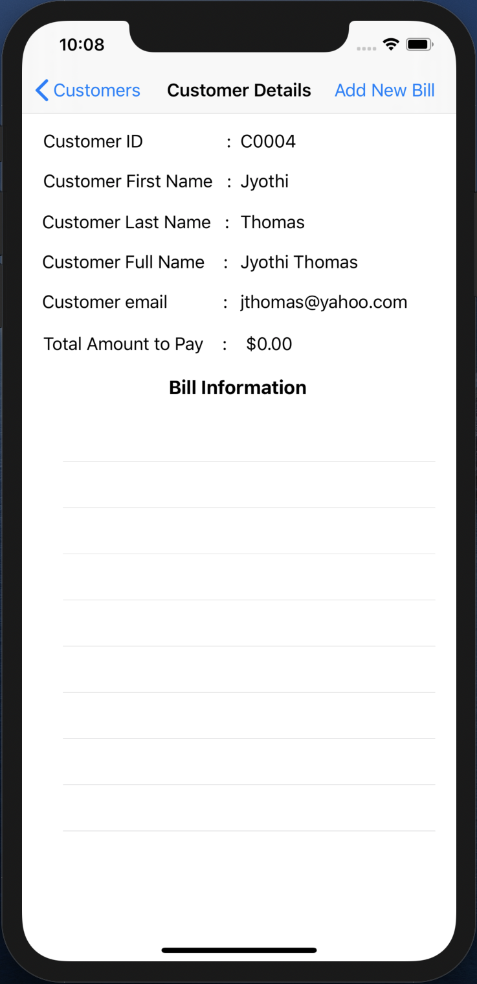

Fig 23. Customer with no bill

* This customer has no bill.
* The Total Amount to Pay is $0.00
* Bill can be added when required by clicking on the Add New Bill BAR BUTTON.

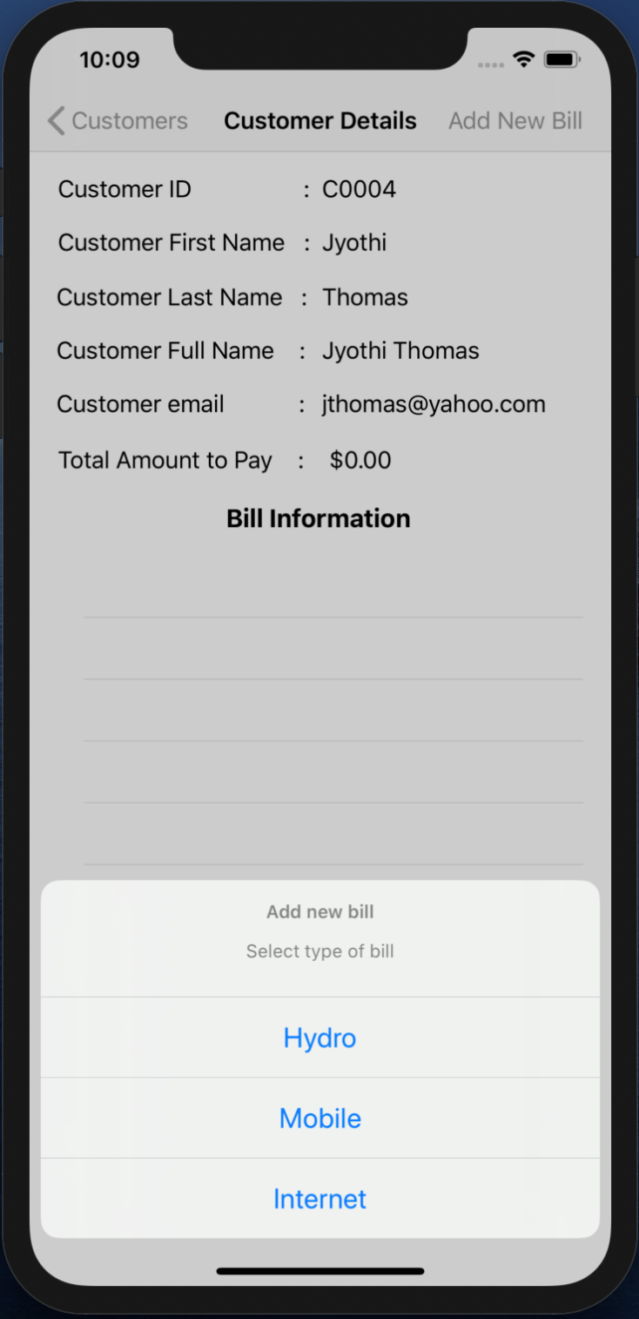

Fig 24. Add New Bill

* When the Add New Bill BAR BUTTON is clicked an ALERT ACTION SHEET appears that shows the list of bills that can be created.
* A new VIEW CONTROLLER will appear according to the type of the bill selected.

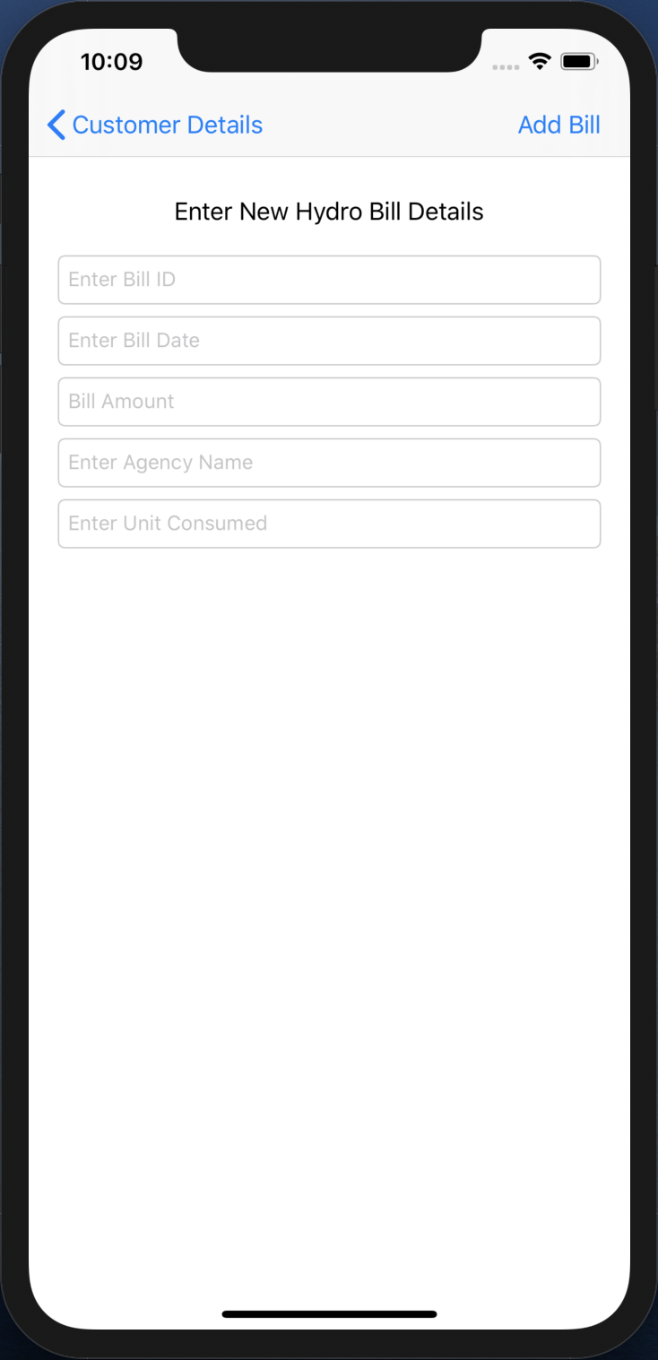

Fig 25. Hydro Bill entry TEXTFIELDs

* When the Hydro Bill type is selected, this VIEW CONTROLLER will appear.
* This VIEW CONTROLLER shows the requirements that needs to be filled in order to create a new Hydro type of bill.

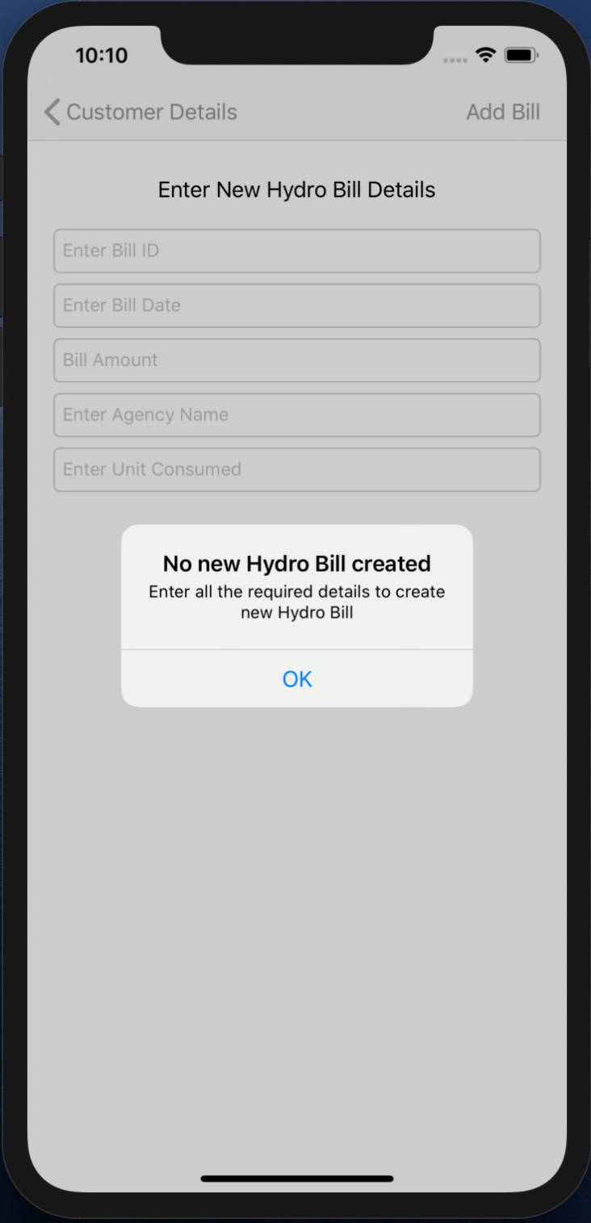

Fig 26. Alert

* When the Save BAR BUTTON is pressed without filling any of the fields then an ALERT will pop up with a significant type of message asking to fill the required details to create the new Hydro Bill.

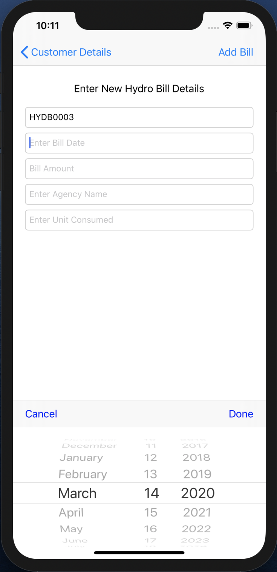

Fig 27. DATE PICKER

* When the Bill Date TEXTFIELD is clicked to enter the Date then a DATE PICKER appears on the screen and the date is selected using the DATE PICKER and Done BUTTON on the Toolbar is pressed and that selected date is filled in the Date TEXTFIELD.

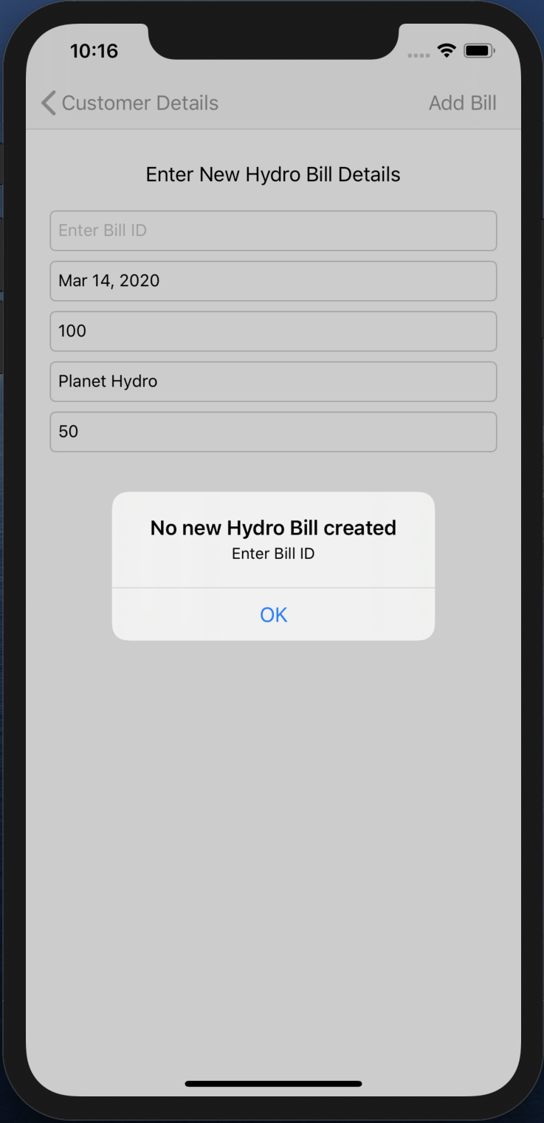

Fig 28. Alert

* An alert will pop up, when Hydro Bill ID is not filled.

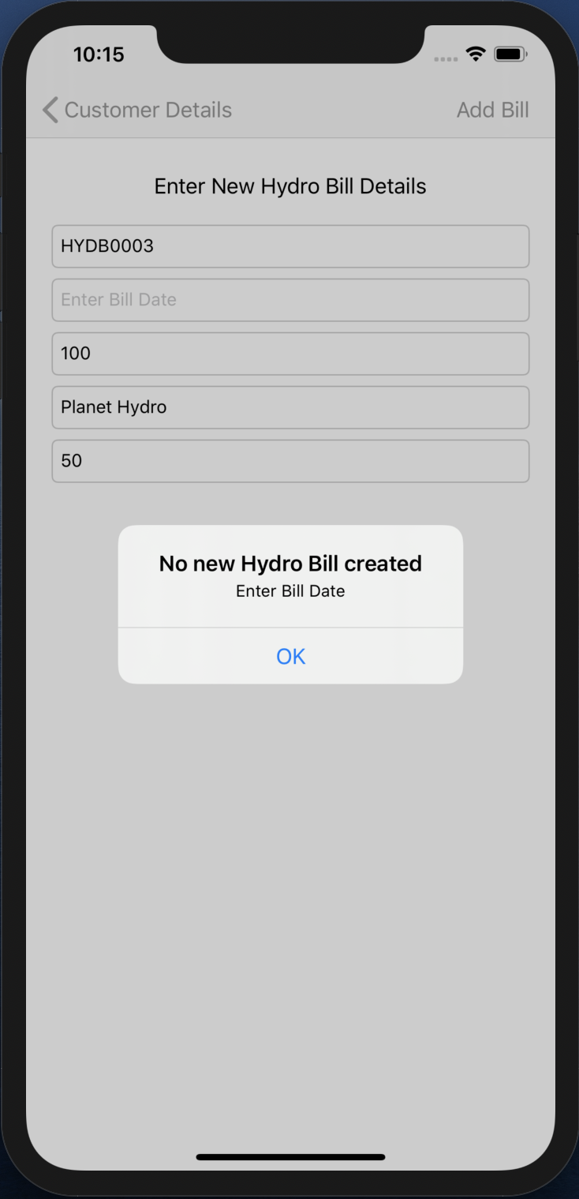

Fig 29. Alert

* An alert will pop up, when Hydro Bill Date is not filled.

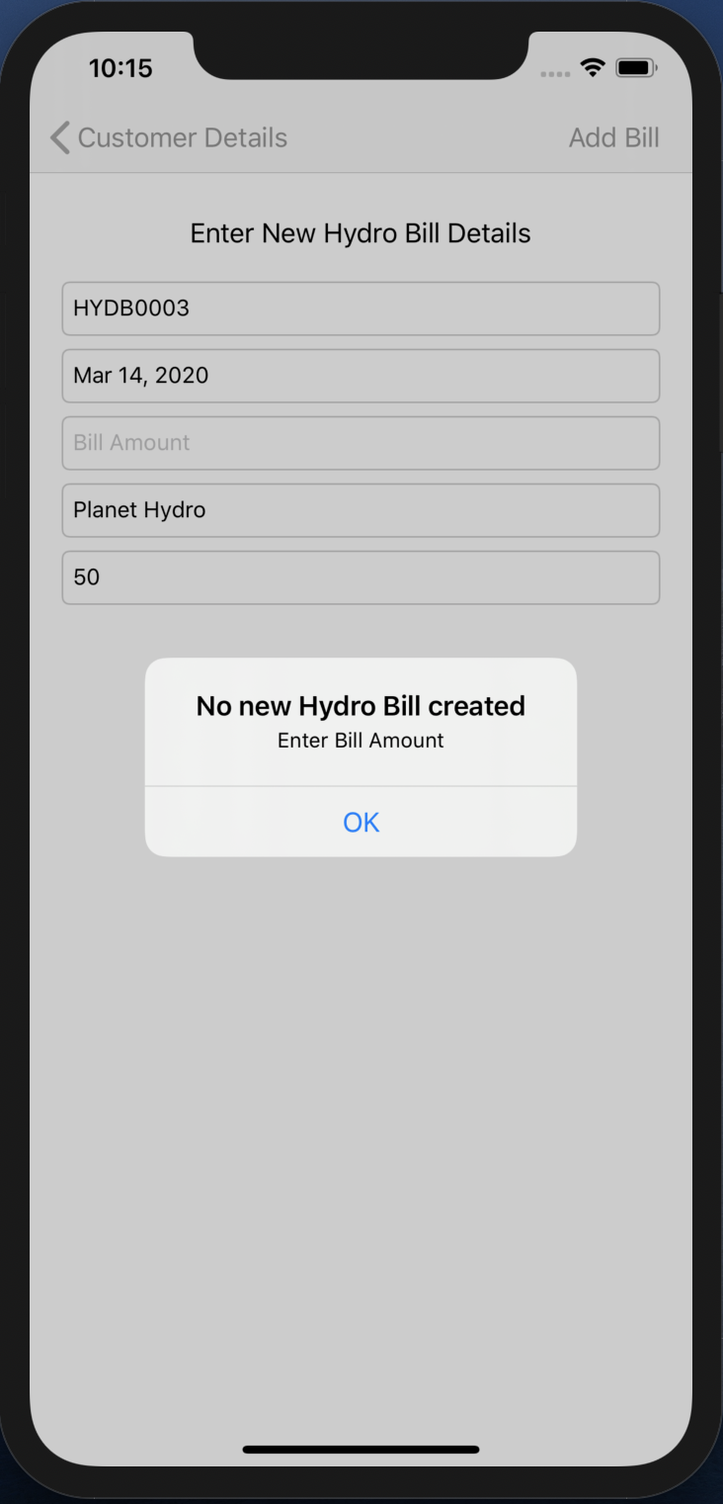

Fig 30. Alert

* An alert will pop up, when Hydro Bill Amount is not filled.

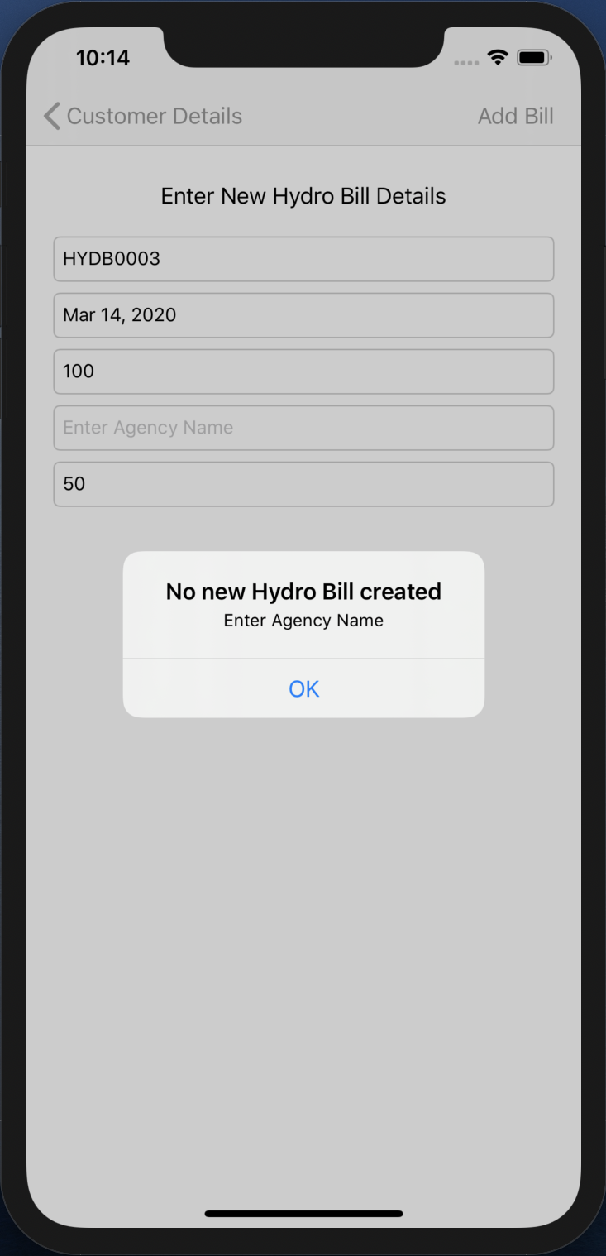

Fig 31. Alert

* An alert will pop up, when Hydro Bill Agency Name is not filled.

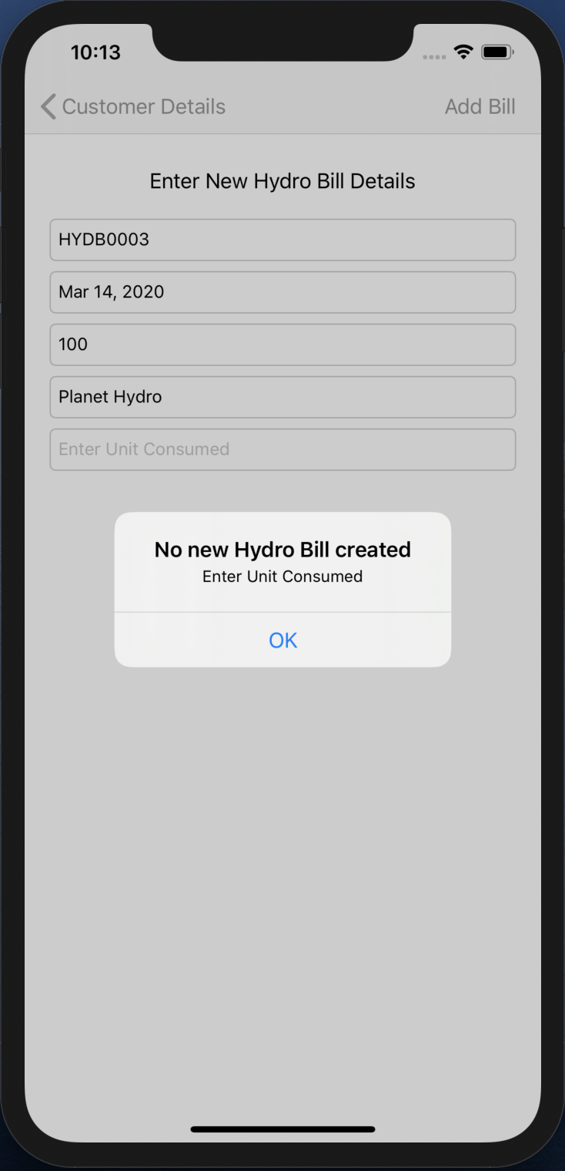

Fig 32. Alert

* An alert will pop up, when Hydro Bill Unit Consumed field is not filled.

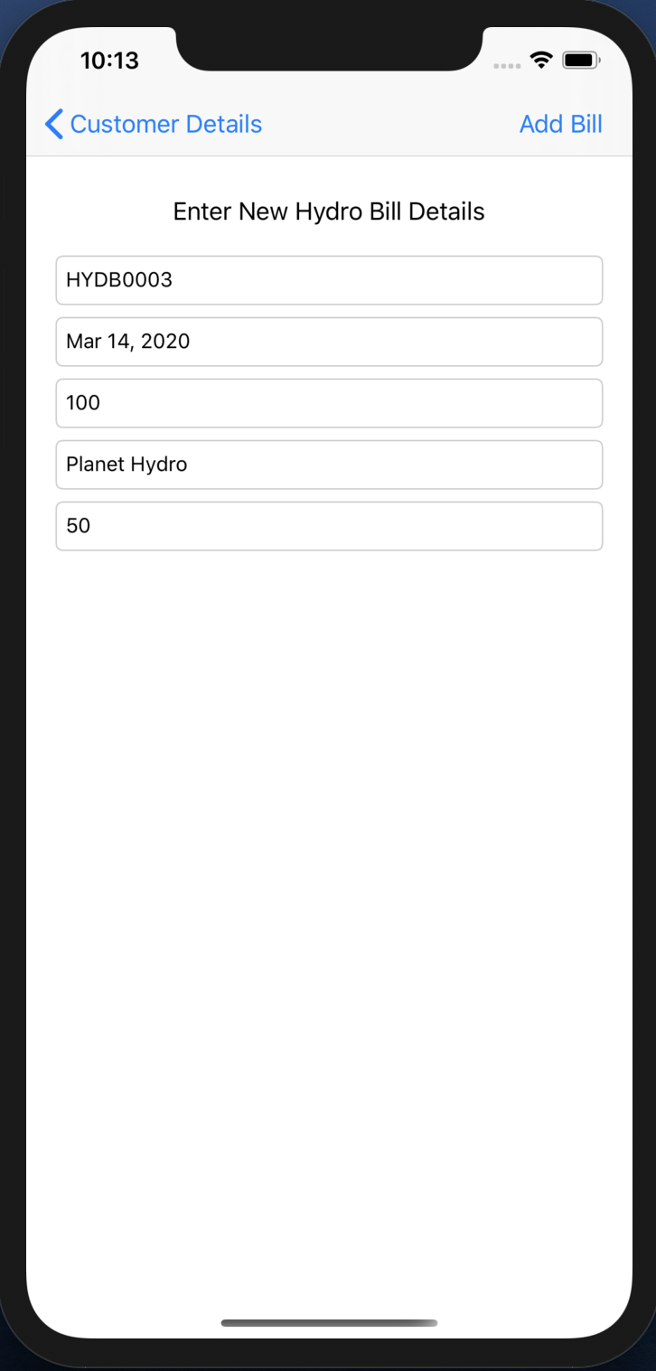

Fig 33. New Hydro Bill details entered

* All the details are filled and Save BAR BUTTON is pressed.
* This will create a new Hydro Bill object and pop this VIEW CONTROLLER.

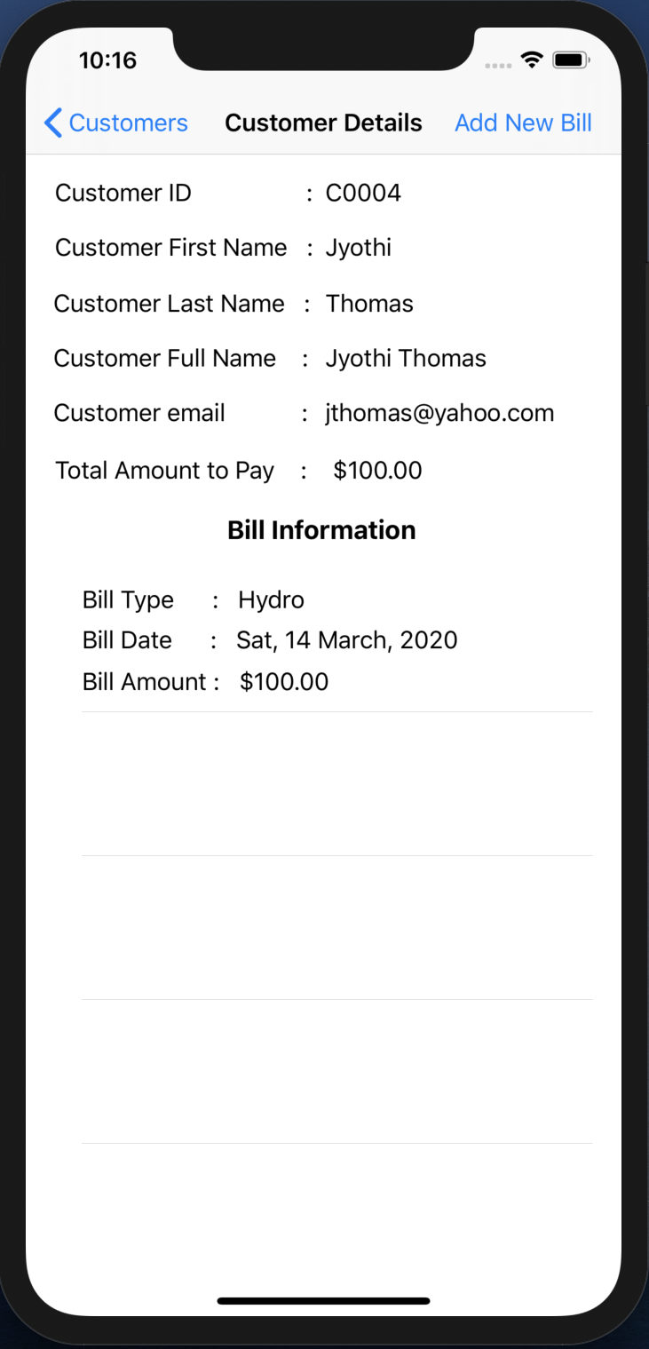

Fig 34. New Hydro Bill appears in Bill Information TABLE VIEW

* As the new Hydro Bill is added, the Bill Information TABLE VIEW gets updated and the Total Amount to Pay is also updated according to the Bill Amount of the new Bill added.

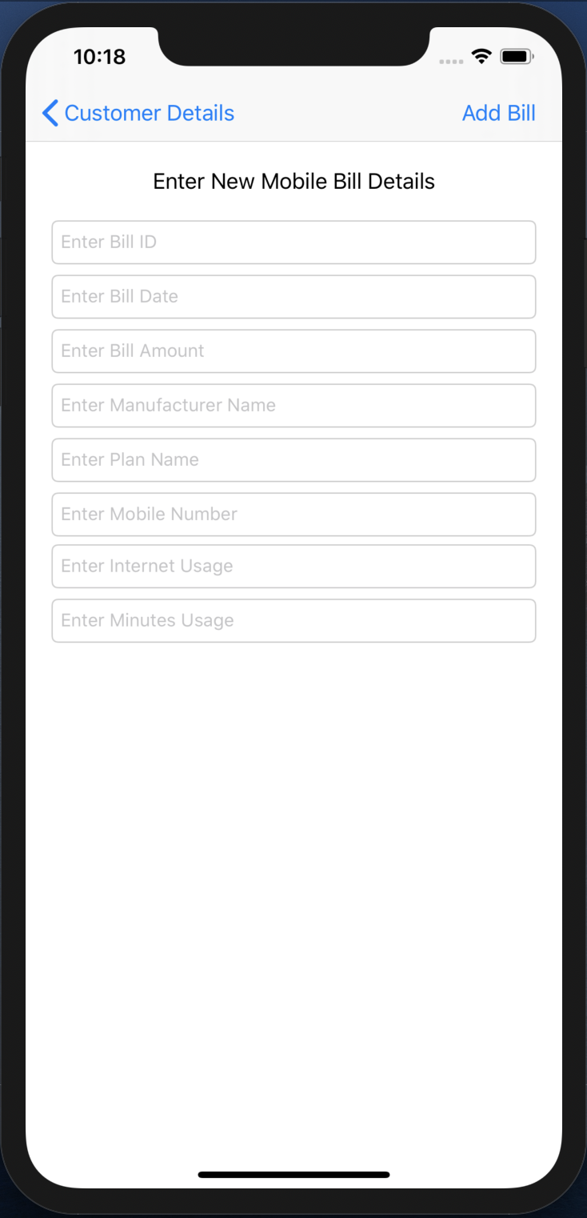

Fig 35. Mobile Bill entry TEXTFIELDs

* When the Mobile Bill type is selected, this VIEW CONTROLLER will appear.
* This VIEW CONTROLLER shows the requirements that needs to be filled in order to create a new Mobile type of bill.

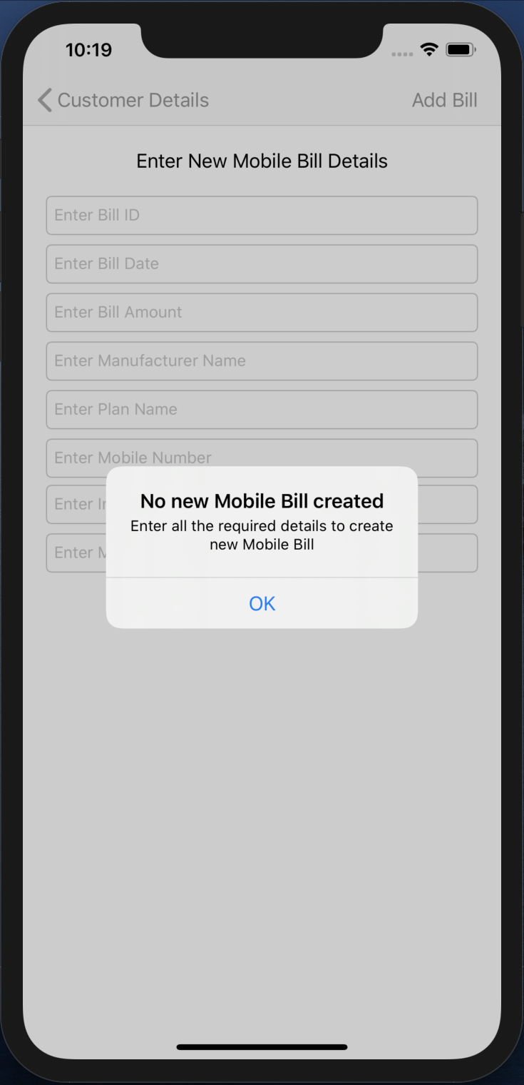

Fig 36. Alert

* When the Save BAR BUTTON is pressed without filling any of the fields then an ALERT will pop up with a significant type of message asking to fill the required details to create the new Mobile Bill.

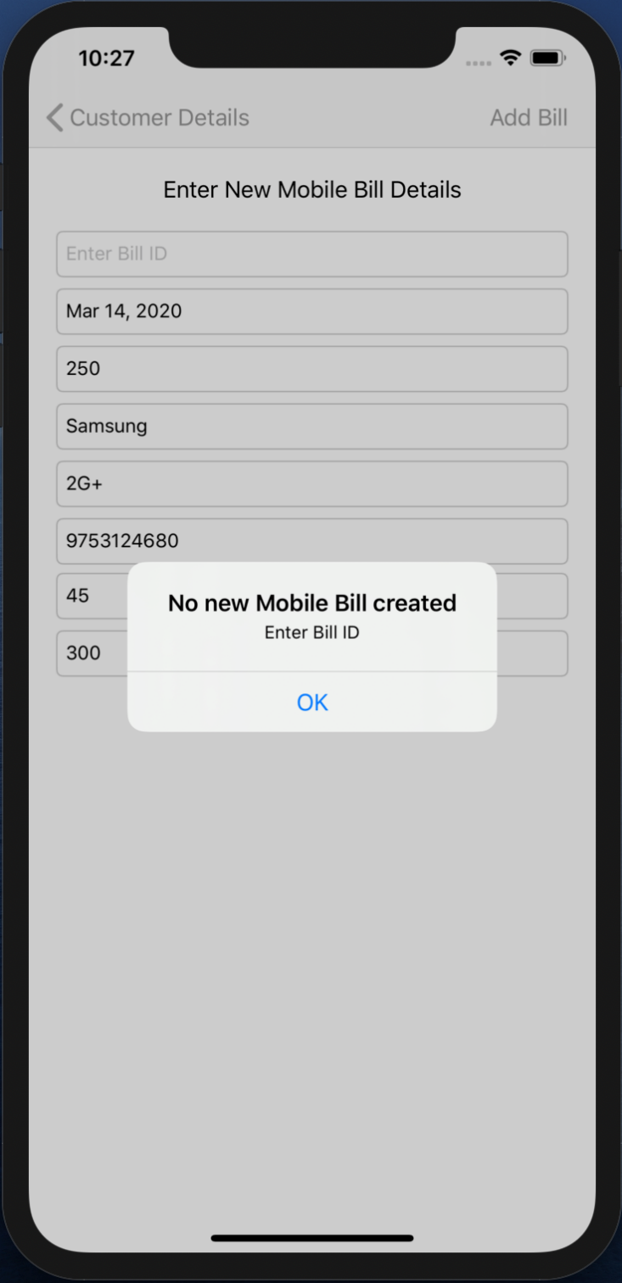

Fig 37. Alert

* An alert will pop up, when Mobile Bill ID is not filled.

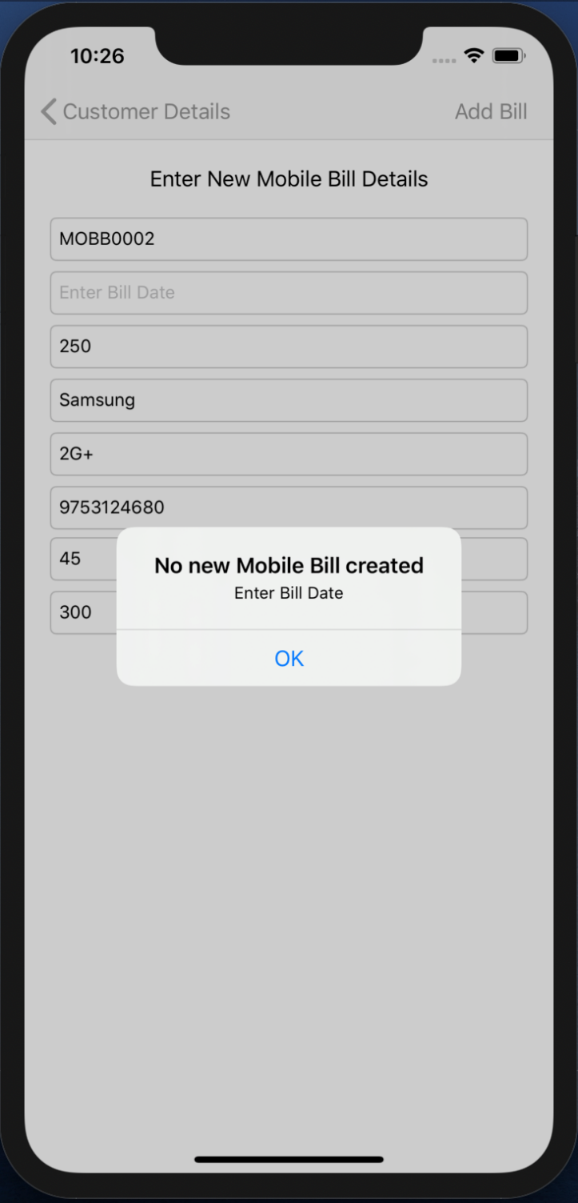

Fig 38. Alert

* An alert will pop up, when Mobile Bill Date is not filled.

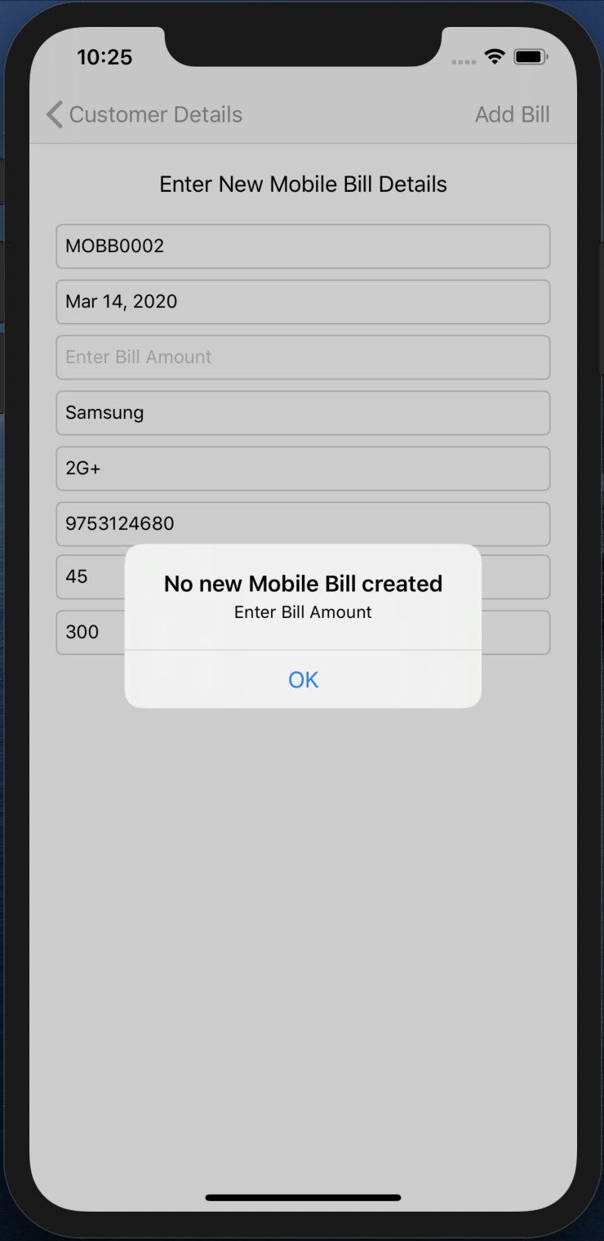

Fig 39. Alert

* An alert will pop up, when Mobile Bill Amount is not filled.

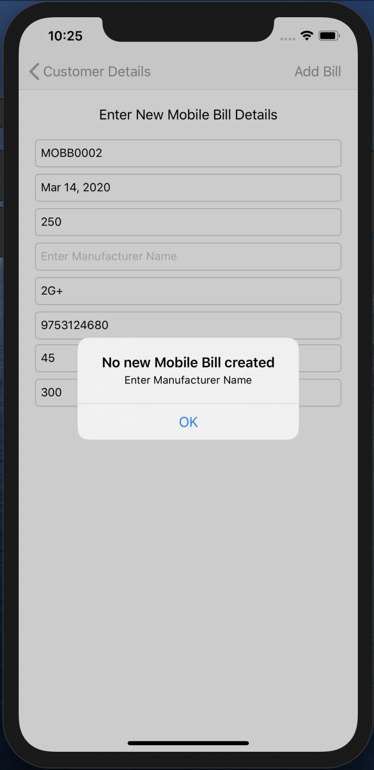

Fig 40. Alert

* An alert will pop up, when Mobile Bill Manufacturer Name is not filled.

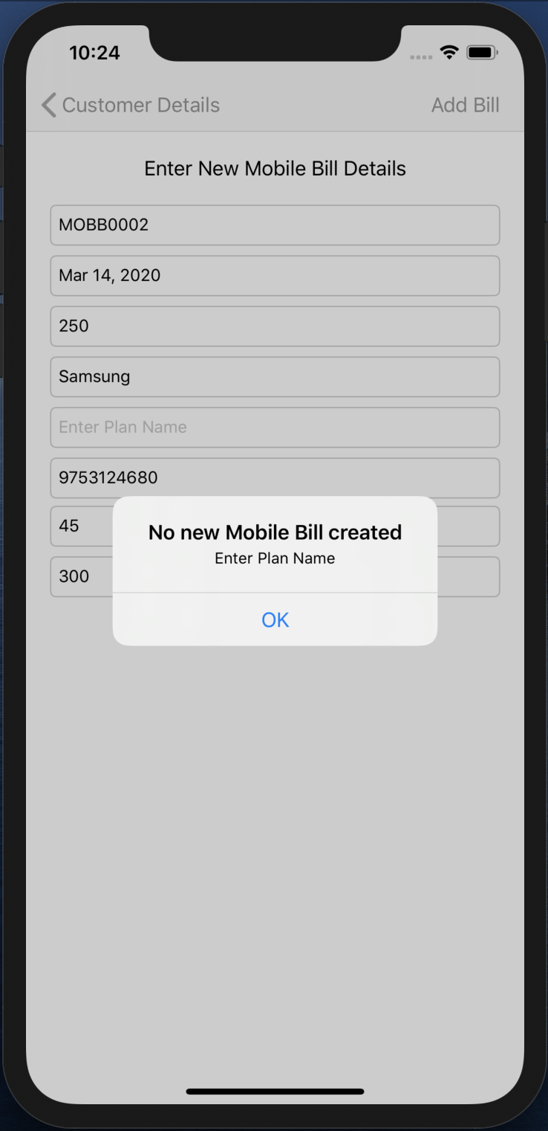

Fig 41. Alert

* An alert will pop up, when Mobile Bill Plan Name is not filled.

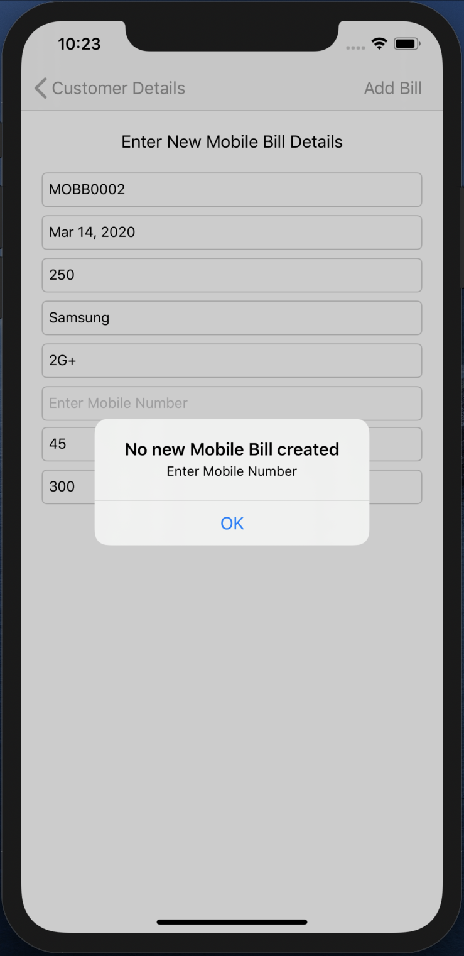

Fig 42. Alert

* An alert will pop up, when Mobile Bill Mobile Number is not filled.

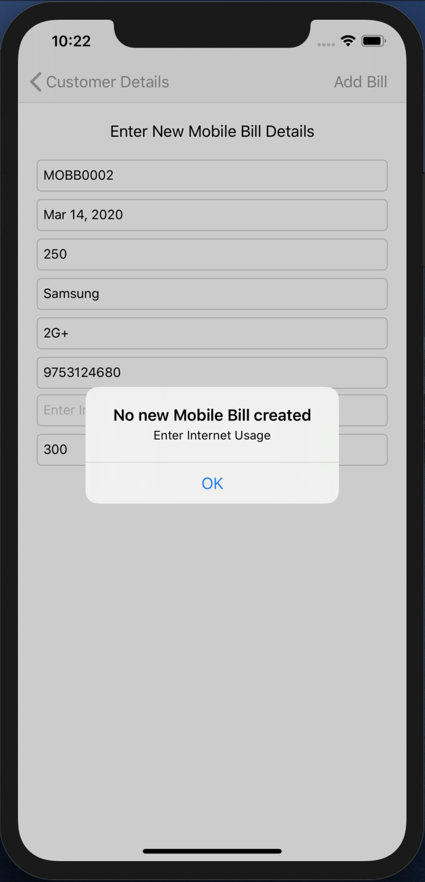

Fig 43. Alert

* An alert will pop up, when Mobile Bill Internet Usage is not filled.

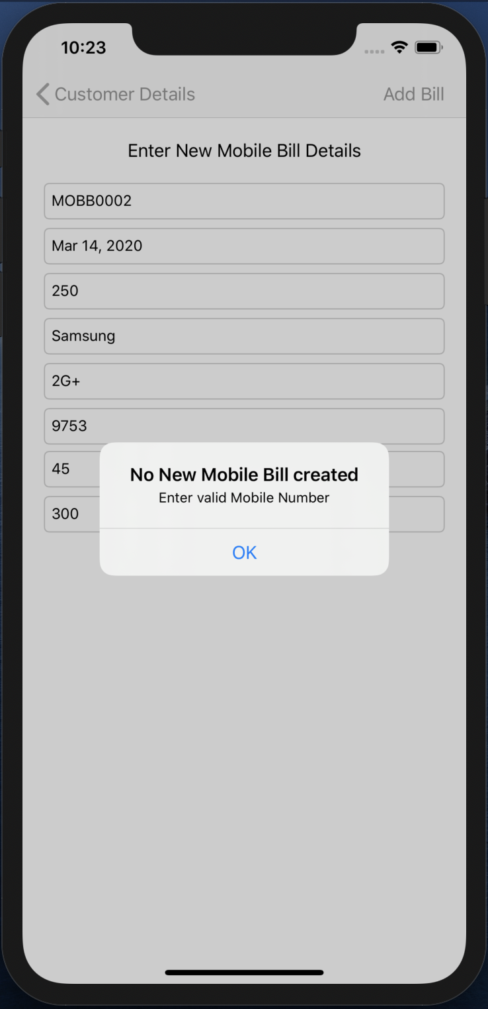

Fig 44. Alert

* An alert will pop up, when in Mobile Bill invalid Mobile Number is filled.

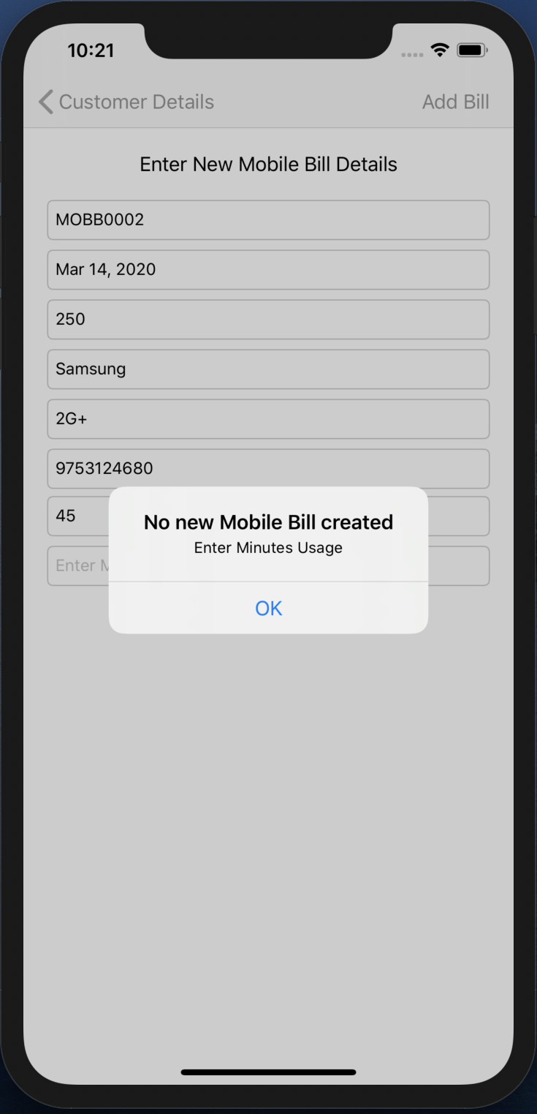

Fig 45. Alert

* An alert will pop up, when Mobile Bill Minutes Usage is not filled.

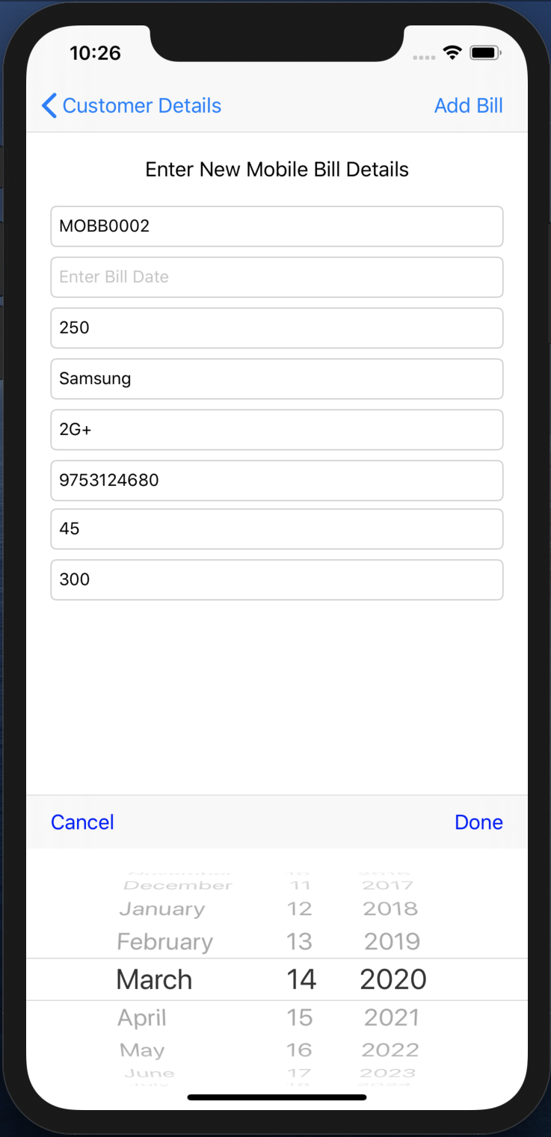

Fig 46. DATE PICKER

* When the Bill Date TEXTFIELD is clicked to enter the Date then a DATE PICKER appears on the screen and the date is selected using the DATE PICKER and Done BUTTON on the Toolbar is pressed and that selected date is filled in the Date TEXTFIELD.

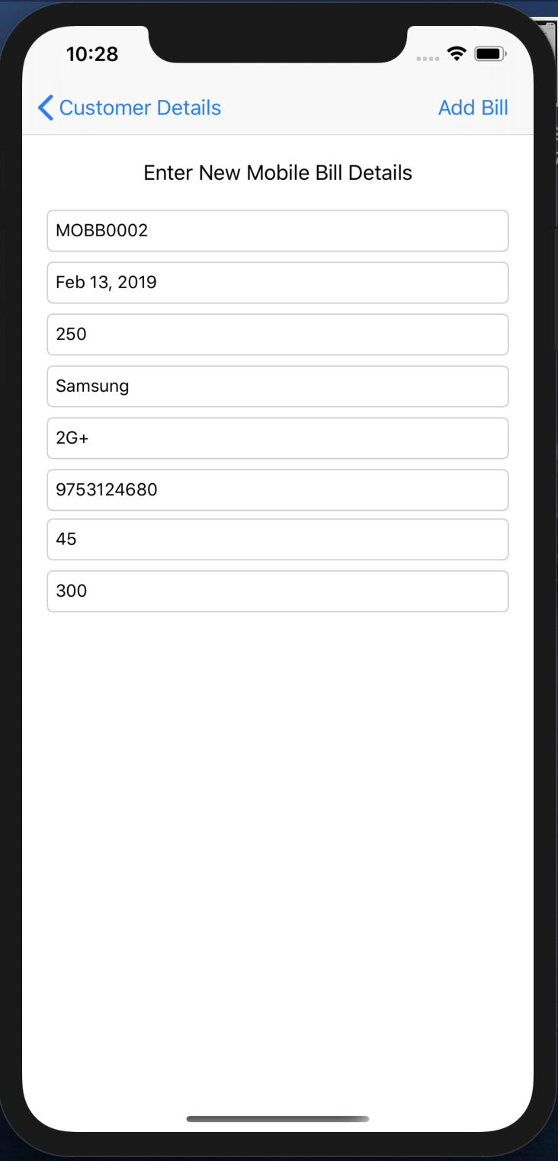

Fig 47. New Mobile Bill details entered

* All the details are filled and Save BAR BUTTON is pressed.
* This will create a new Mobile Bill object and pop this VIEW CONTROLLER.

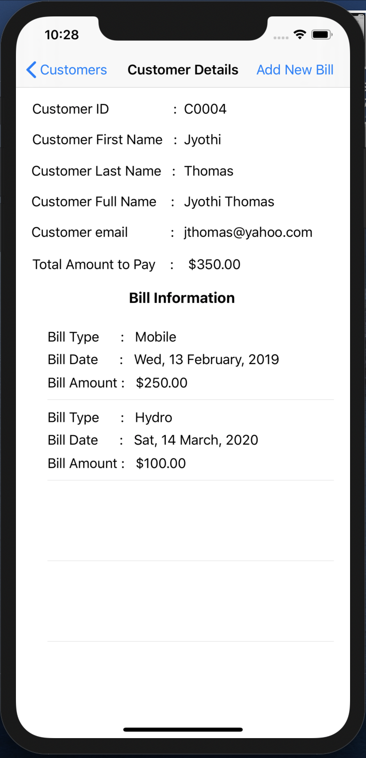

Fig 48. New Mobile Bill appears in Bill Information TABLE VIEW

* As the new Mobile Bill is added, the Bill Information TABLE VIEW gets updated and the Total Amount to Pay is also updated according to the Bill Amount of the new Bill added.

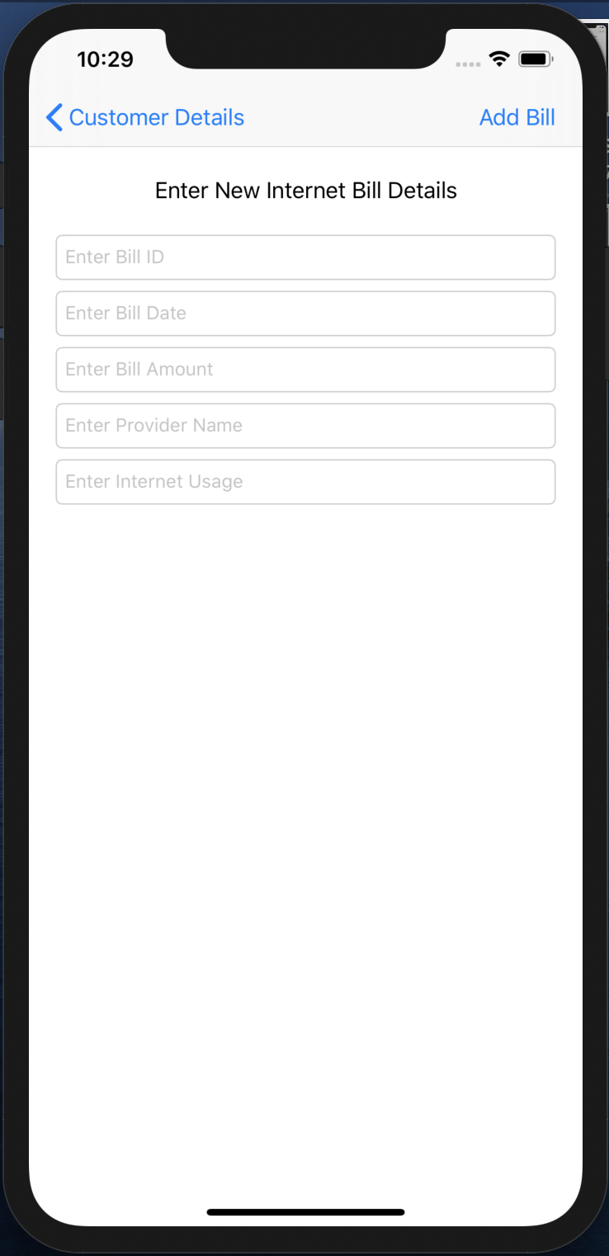

Fig 49. Internet Bill entry TEXTFIELDs

* When the Internet Bill type is selected, this VIEW CONTROLLER will appear.
* This VIEW CONTROLLER shows the requirements that needs to be filled in order to create a new Internet type of bill.

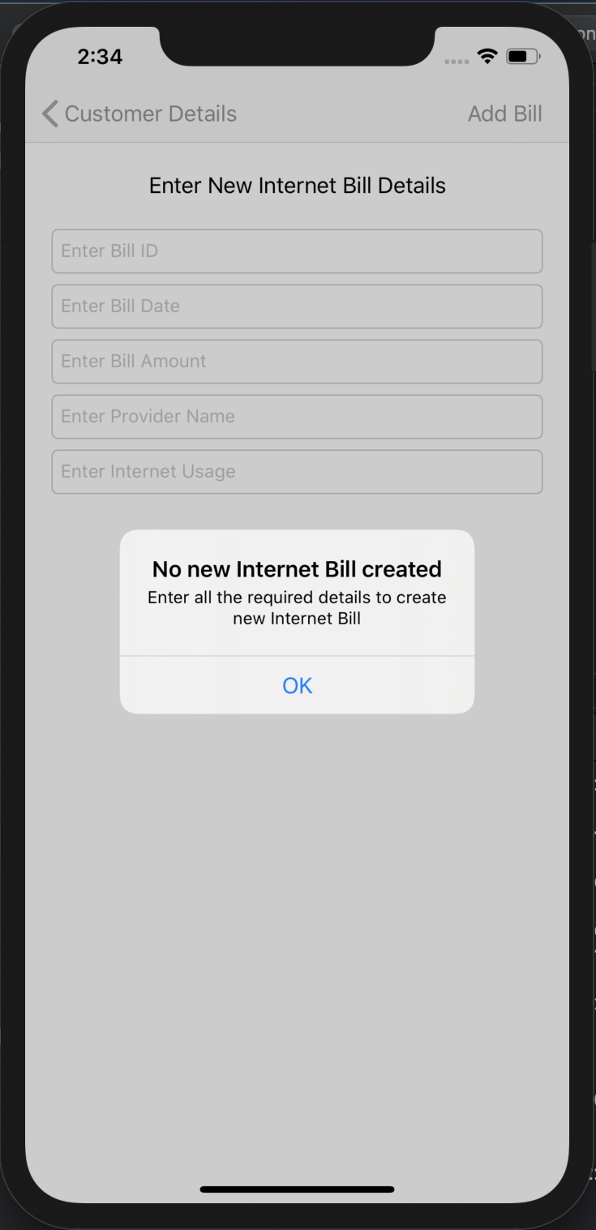

Fig 50. Alert

* When the Save BAR BUTTON is pressed without filling any of the fields then an ALERT will pop up with a significant type of message asking to fill the required details to create the new Internet Bill.

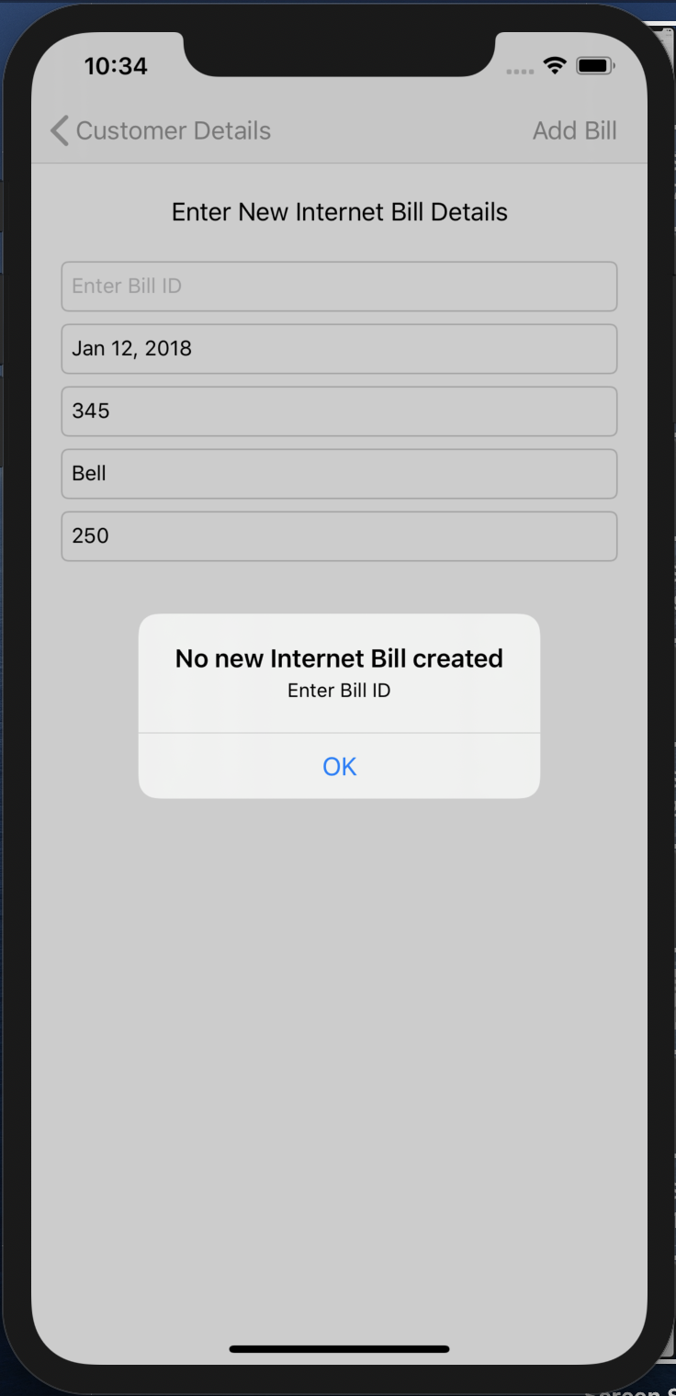

Fig 51. Alert

* An alert will pop up, when Internet Bill ID is not filled.

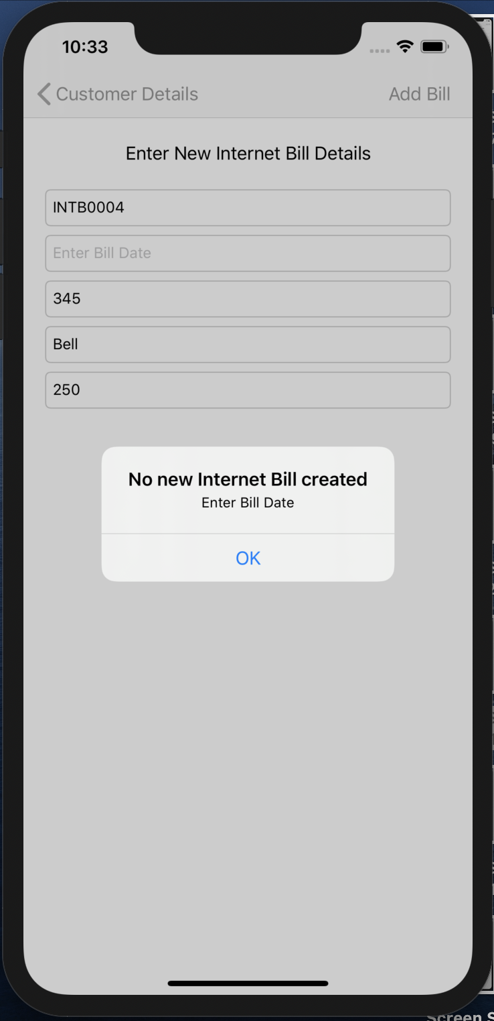

Fig 52. Alert

* An alert will pop up, when Internet Bill Date is not filled.

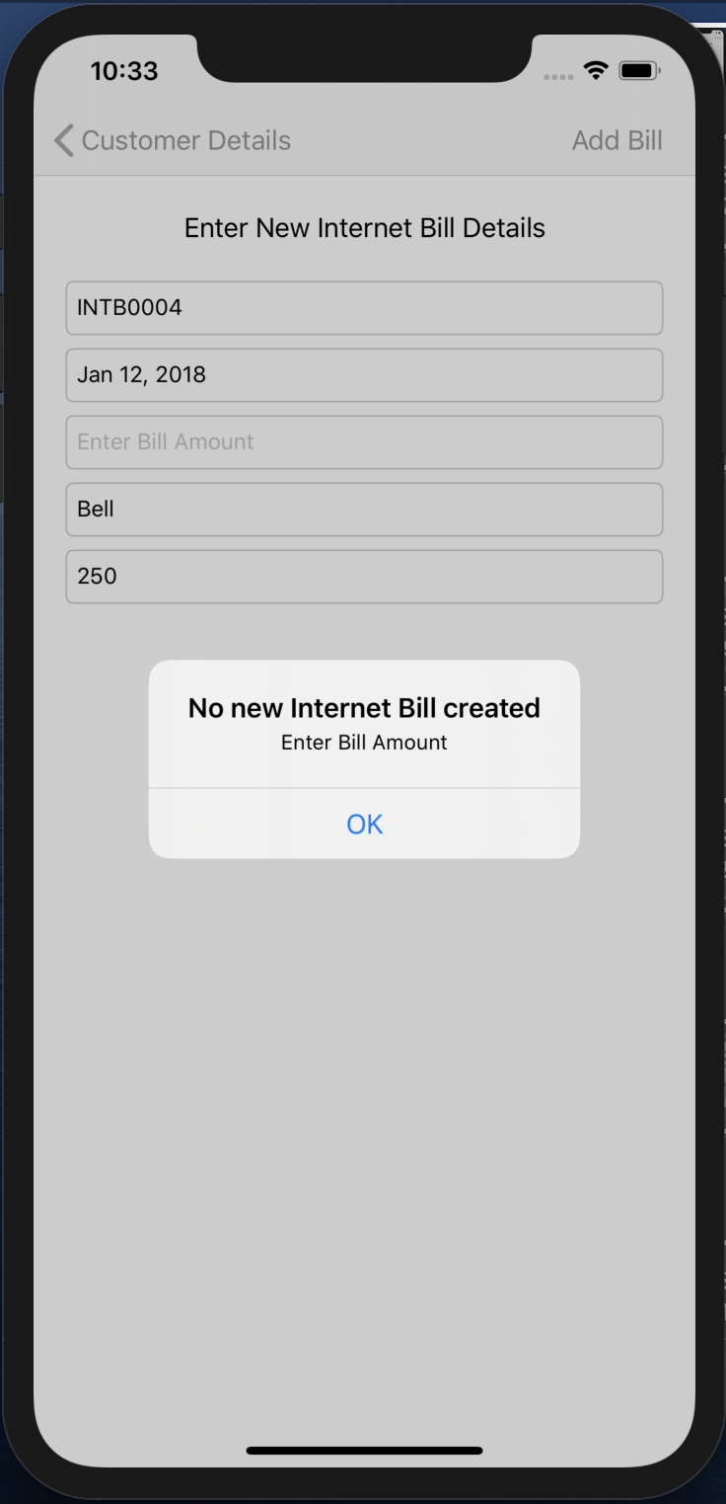

Fig 53. Alert

* An alert will pop up, when Internet Bill Amount is not filled.

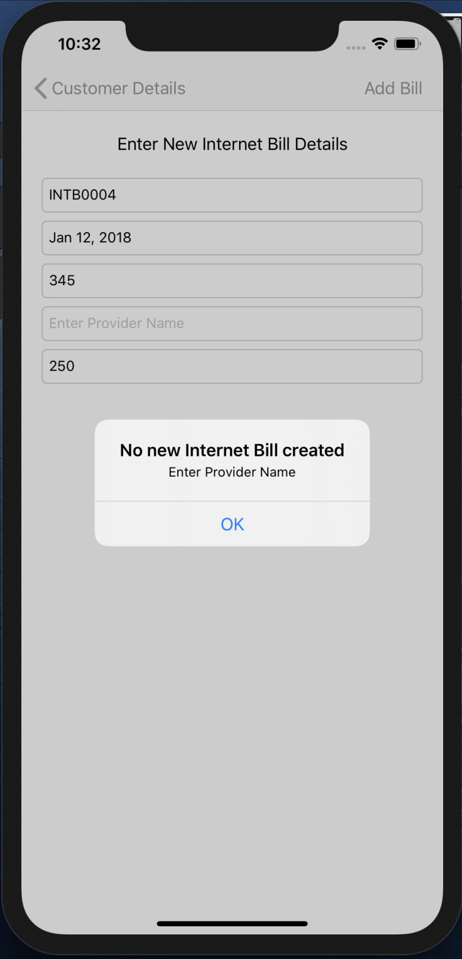

Fig 54. Alert

* An alert will pop up, when Internet Bill Provider Name is not filled.

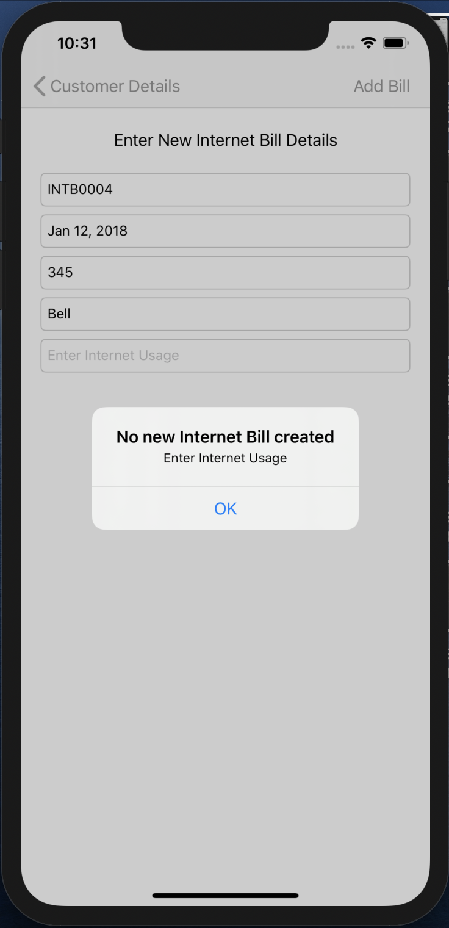

Fig 55. Alert

* An alert will pop up, when Internet Bill Internet Usage is not filled.

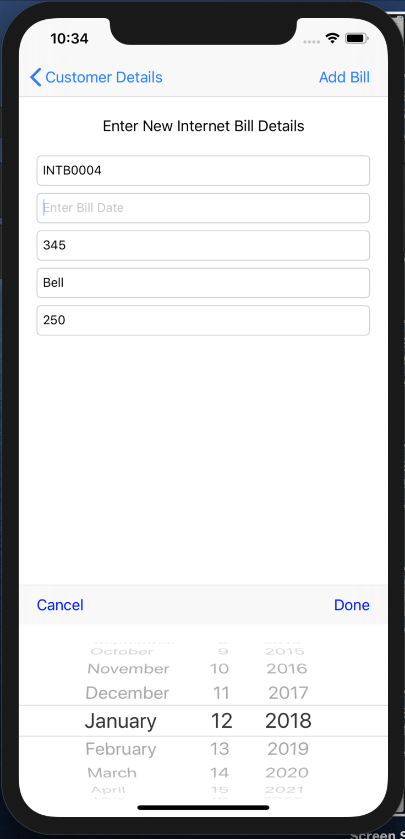

Fig 56. DATE PICKER

* When the Bill Date TEXTFIELD is clicked to enter the Date then a DATE PICEKR appears on the screen and the date is selected using the DATE PICKER and Done BUTTON on the Toolbar is pressed and that selected date is filled in the Date TEXTFIELD.

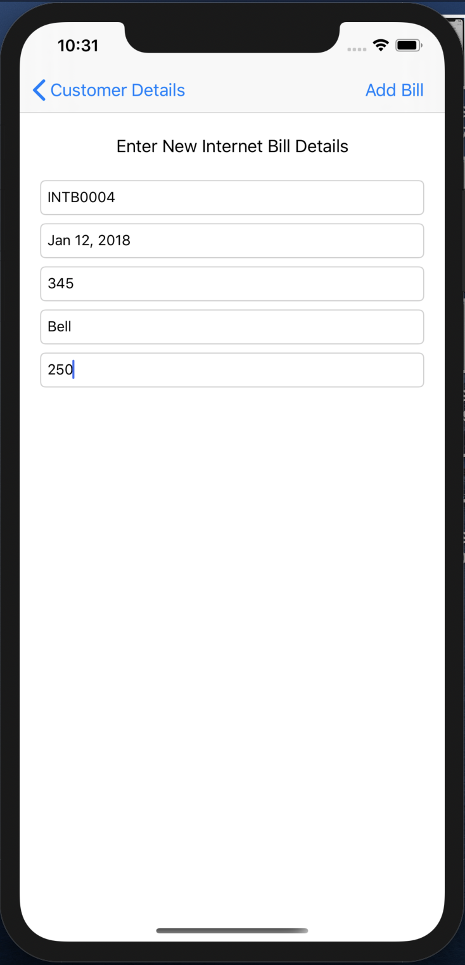

Fig 57. New Internet Bill details entered

* All the details are filled and Save BAR BUTTON is pressed.
* This will create a new Internet Bill object and pop this VIEW CONTROLLER.

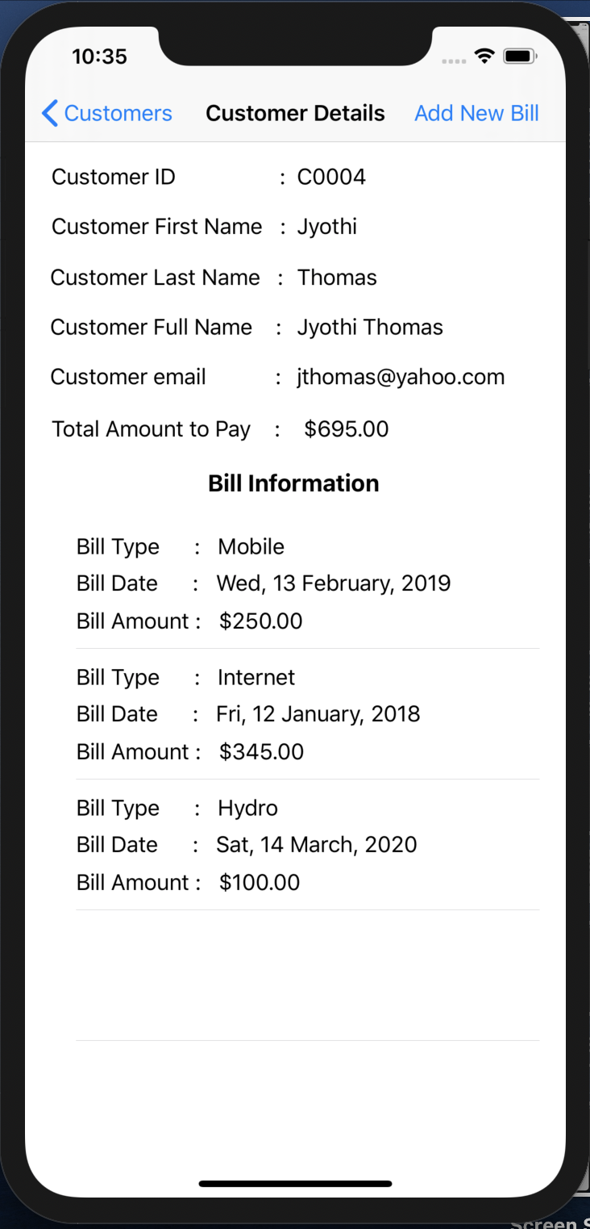

Fig 58. New Internet Bill appears in Bill Information TABLE VIEW

* As the new Internet Bill is added, the Bill Information TABLE VIEW gets updated and the Total Amount to Pay is also updated according to the Bill Amount of the new Bill added.